

**Task:**

Web Browser Forensics & Online Activity Investigation

Saad Naveed

Cybersecurity & Digital Forensics

Week 03

Date: 24th July 2025

Digital Forensics Internee

GitHub:

**Table of Contents**

Objective 3

Tools Used: 3

Questions 1 3

Question 2: 7

Question 3: 12

Question: 04 17

Question 5 19

**Step 2: Check Recent Files** 21

Step 3: Analyze Shellbags 22

Step 4: Correlate with Event Logs (User Login Sessions) 25

Conclusion 29

Summary 30

# Objective

Analyze browser artifacts and system logs to trace web-based activities, such as visited websites, downloads, phishing attempts, or data exfiltration through cloud platforms.

# Tools Used:

* VirusTotal
* Event Viewer
* Shell Bag
* Winprefetchview
* Browserhistoryview
* DB Browser (SQLite)

# Questions 1

Extract Browser Artifacts From a disk or live image, extract artifacts from Chrome, Firefox, or Edge profiles:

▪ History

▪ Downloads

▪ Cookies

▪ Autofill / Stored passwords

▪ Bookmarks

I follow these steps:

C:\Users\sc\AppData\Roaming\Opera Software\Opera Stable\

I navigated to the Opera profile path:  
C:\Users\sc\AppData\Roaming\Opera Software\Opera Stable\  
and copied key forensic artifacts (History, Cookies, Downloads, Bookmarks, Login Data) to a working folder C:\ Desktop\WeeksDFin\ for further analysis.

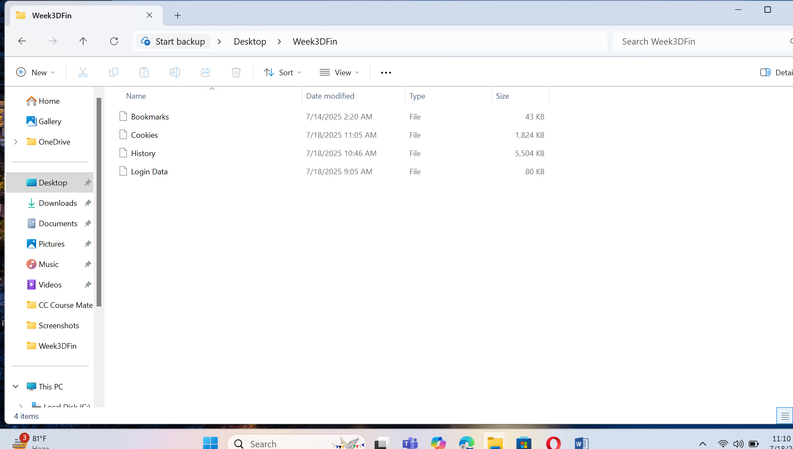

Now run SQLit DB Browser.

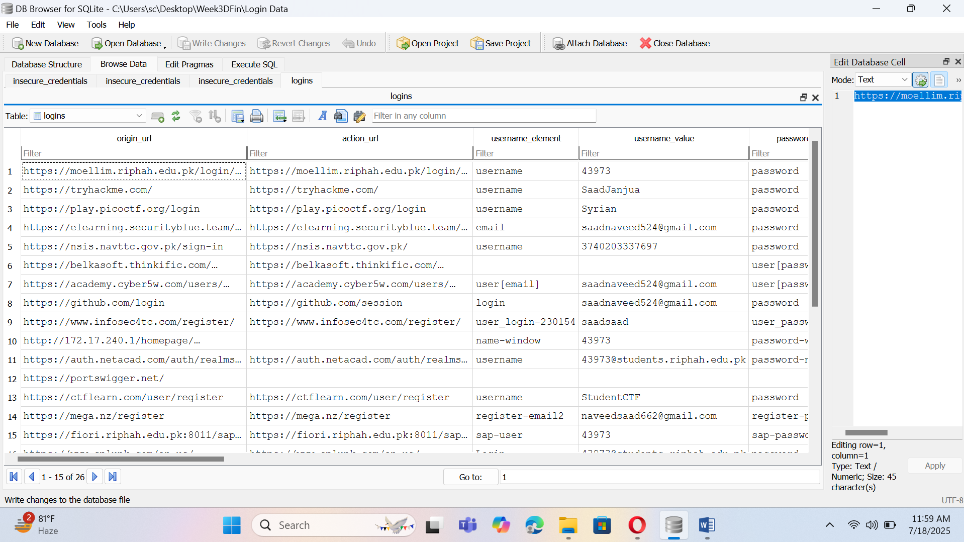And run History Files.

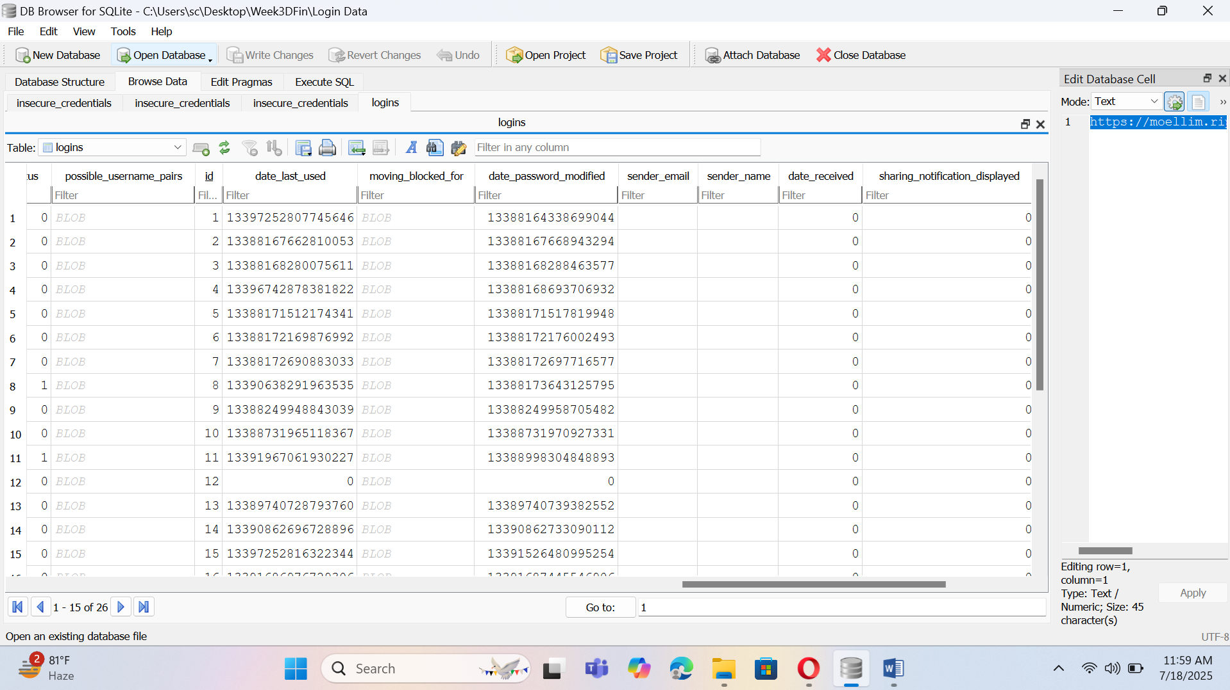

Now open Cookies File.

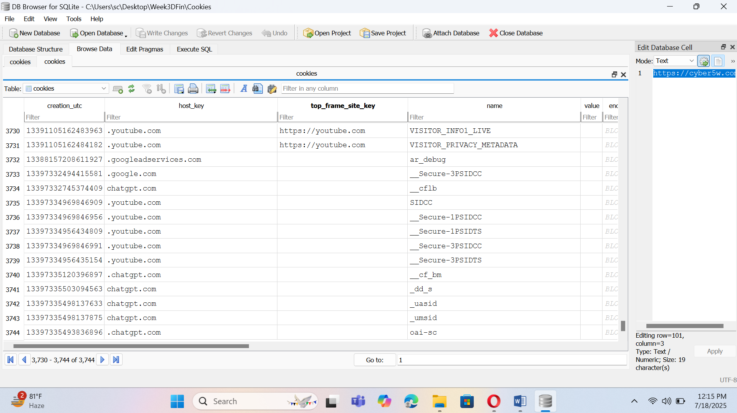

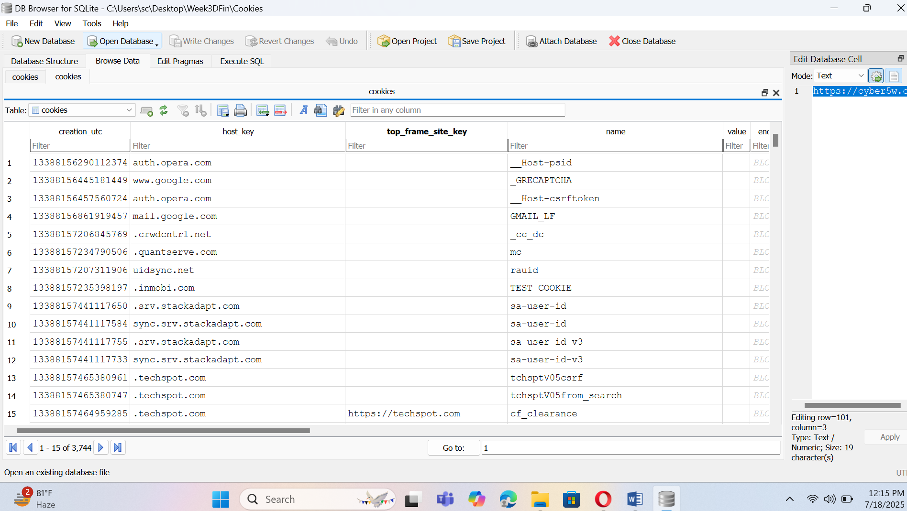

Now open Bookmark file.

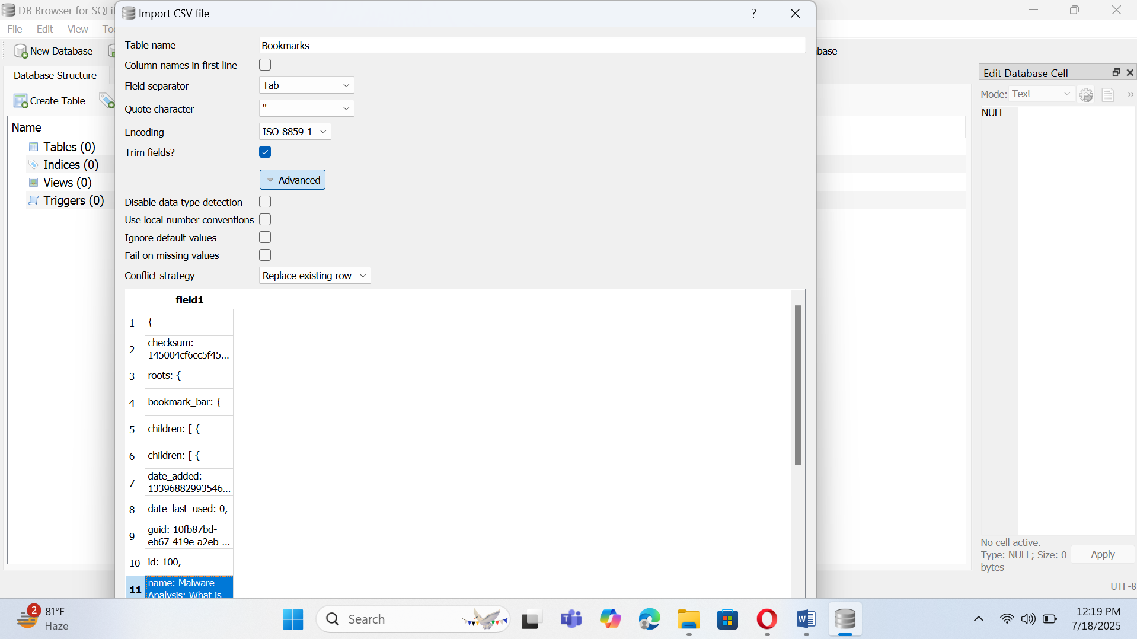

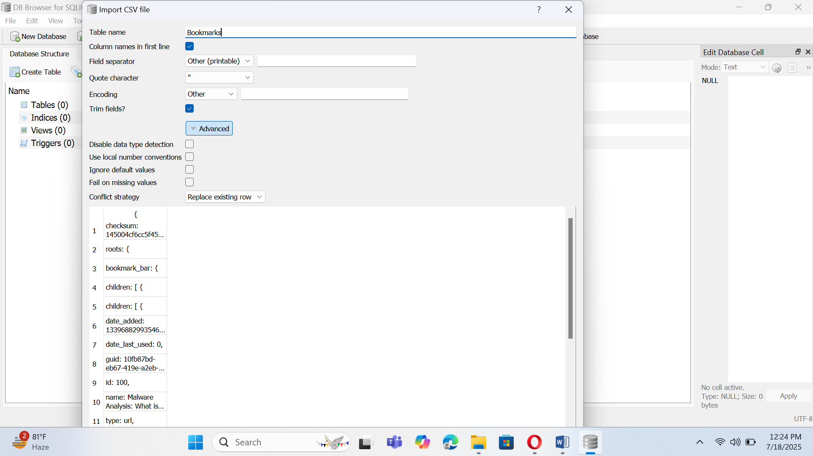

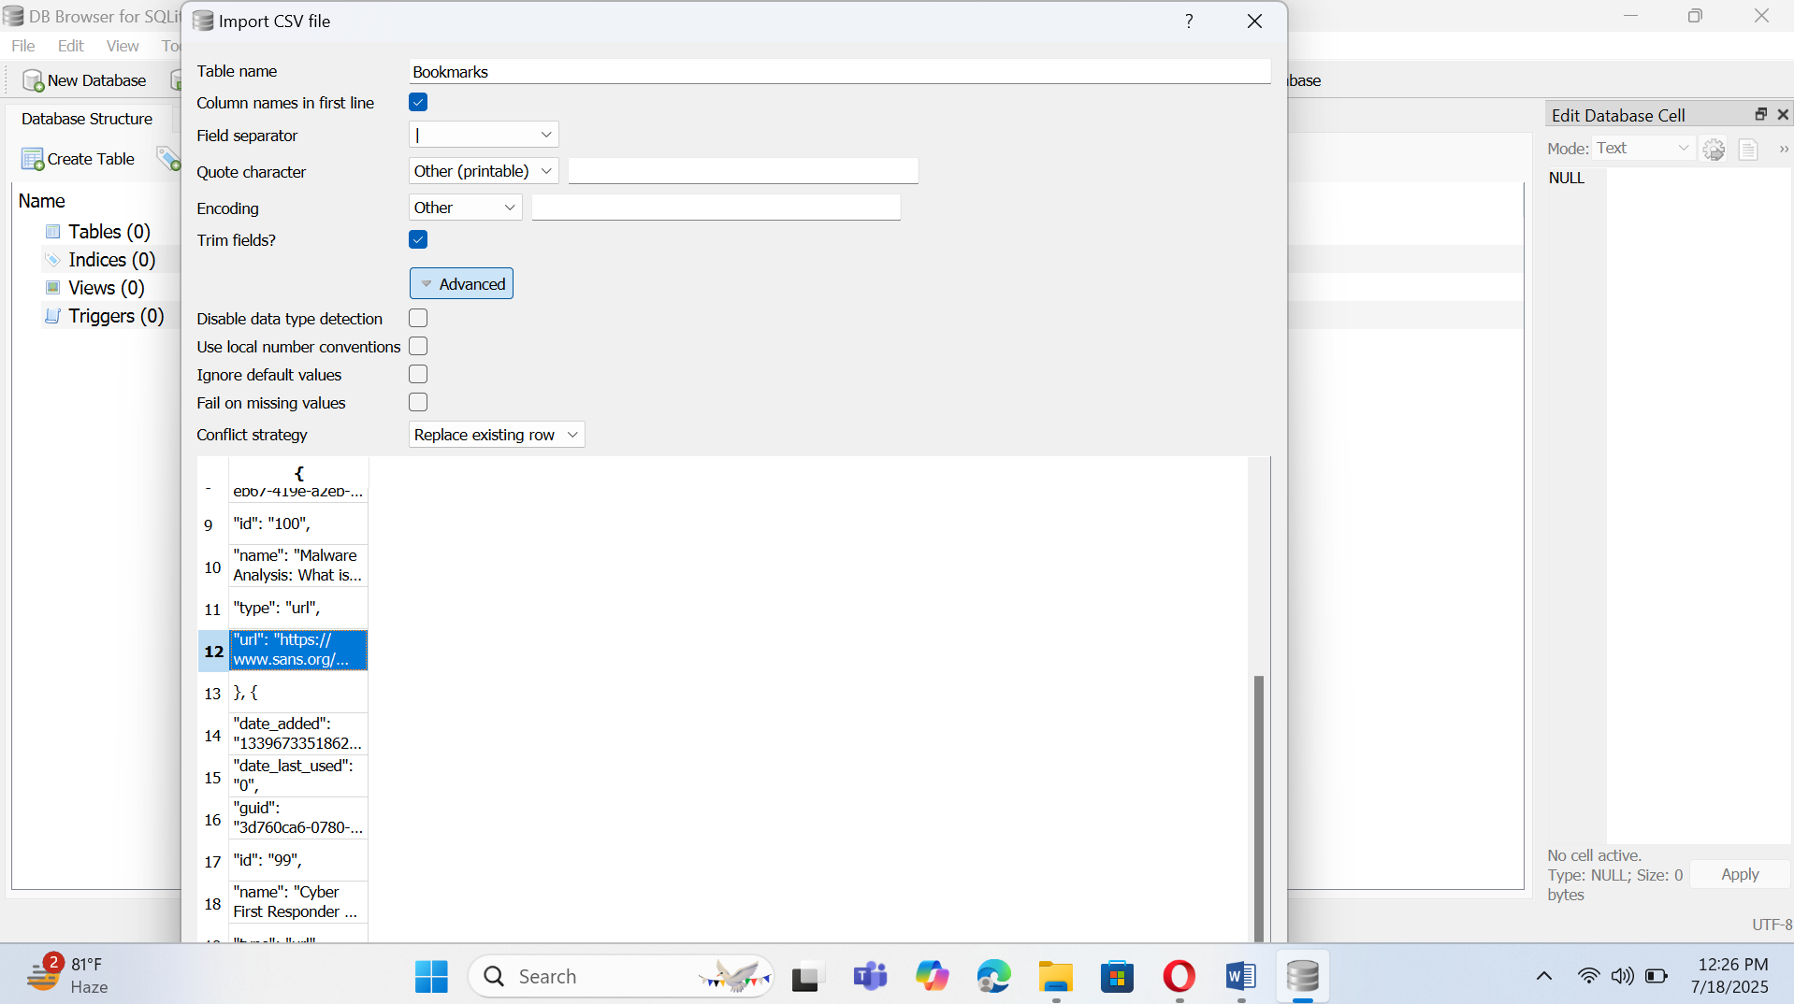

Question 2: Identify Suspicious Web Activity

Look for:

▪ Visits to known malicious/phishing domains

▪ Cloud storage uploads (Dropbox, Google Drive, Mega)

▪ Use of private browsing or VPN proxies

▪ Logins to unknown or suspicious email providers

Solution:

Now I run tool Browser History View and then open history file in this tool.

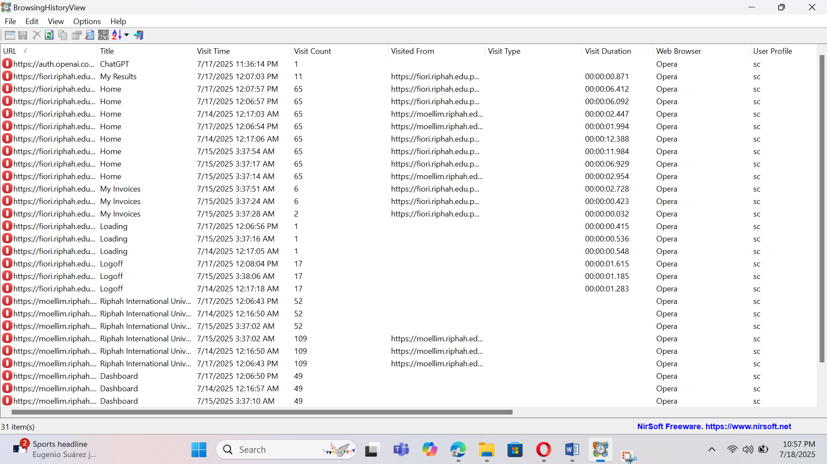

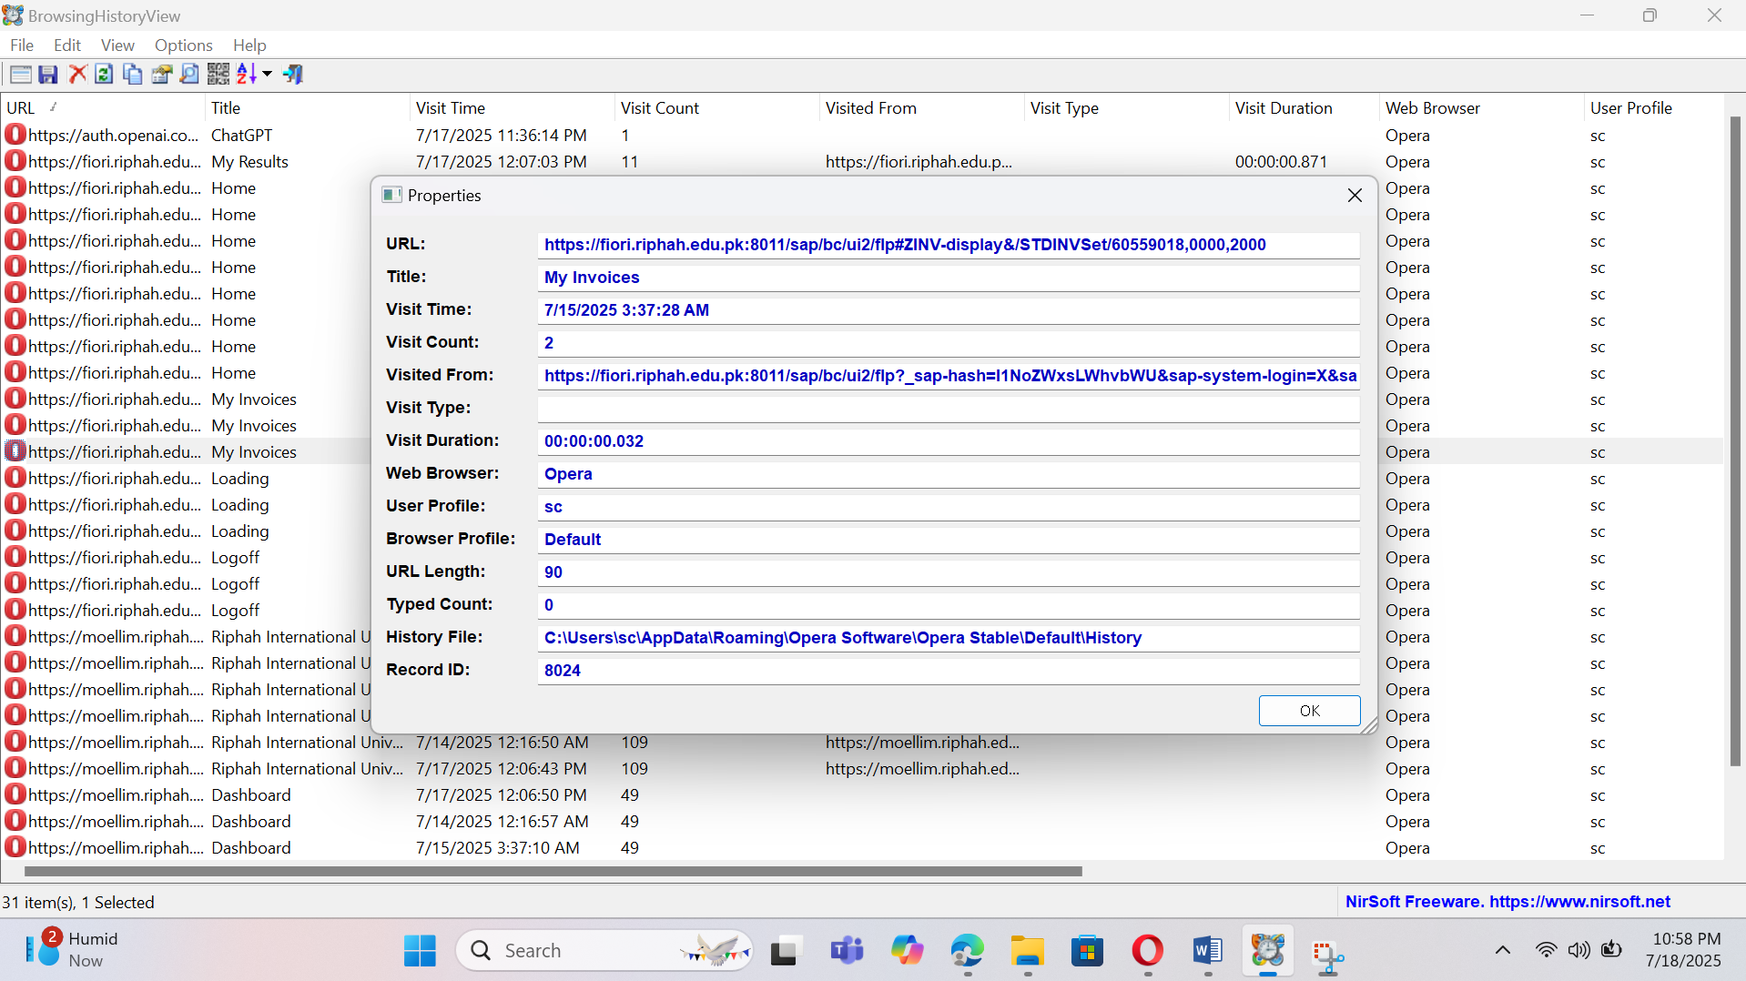

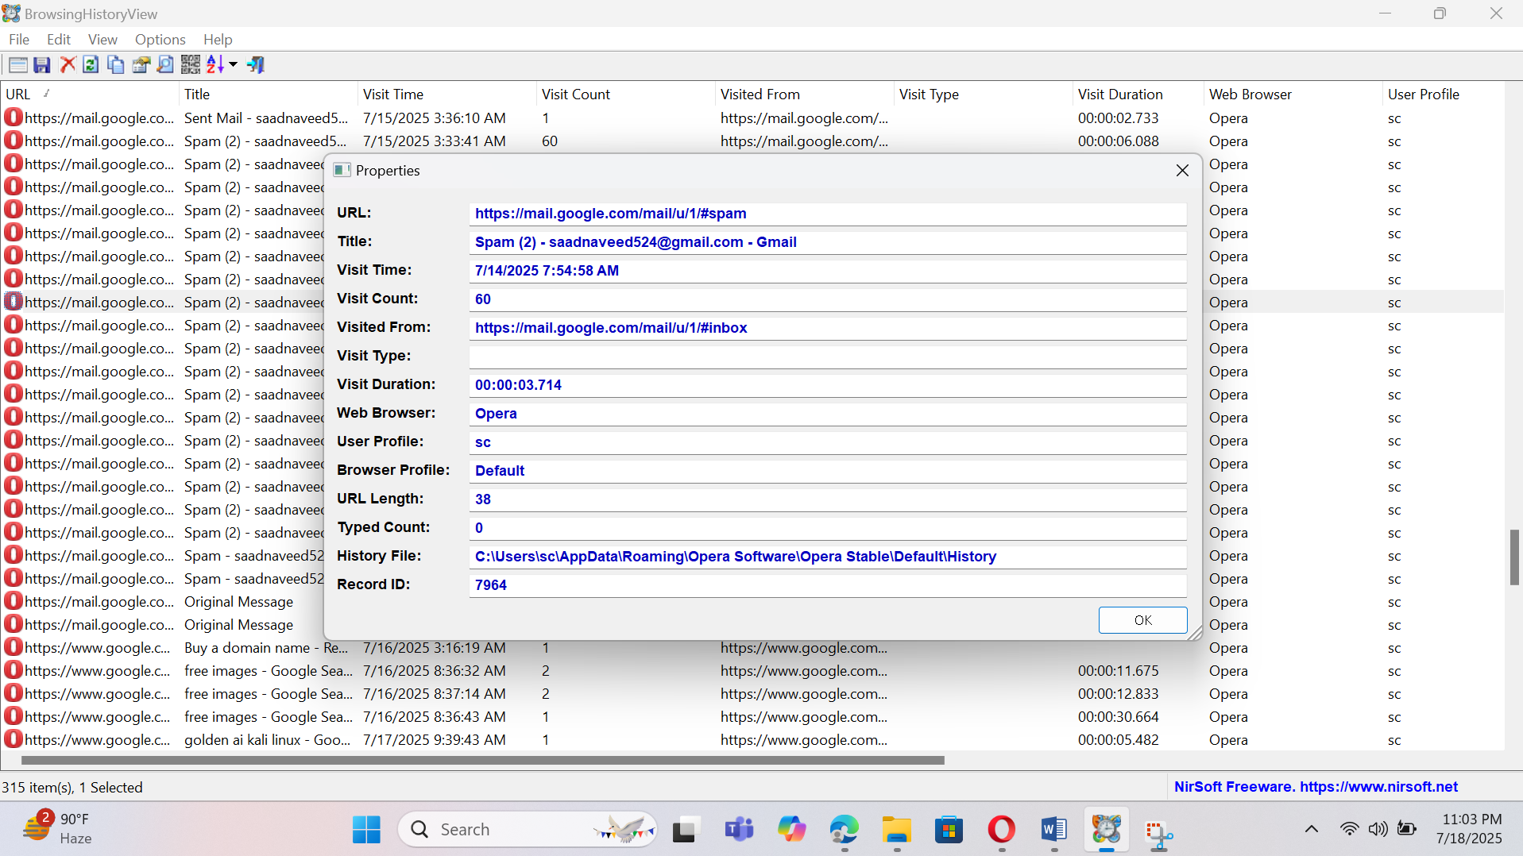Spams Emails.

Use **Virus Total:**

**Copy url and paste in virus total.**

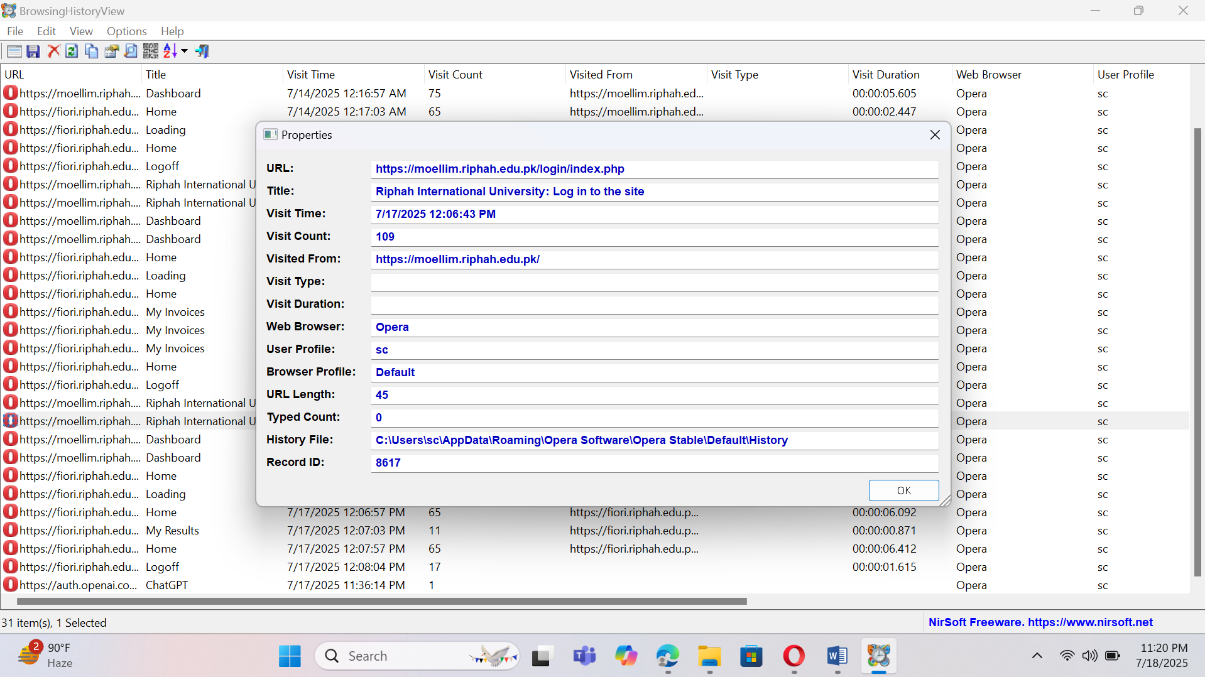

Now run virus total

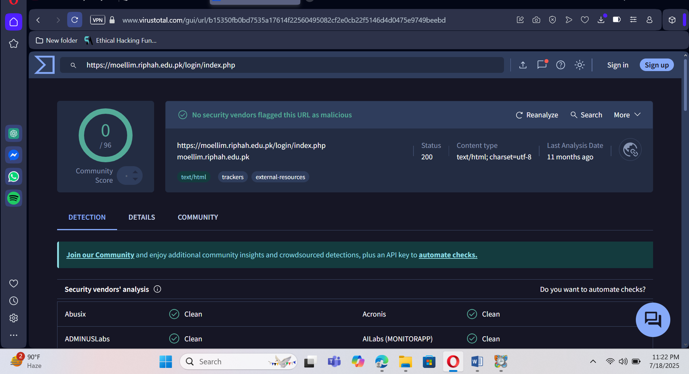

Now analyze Cookie file through Browser History View

Open Cookie file in Brower History View.

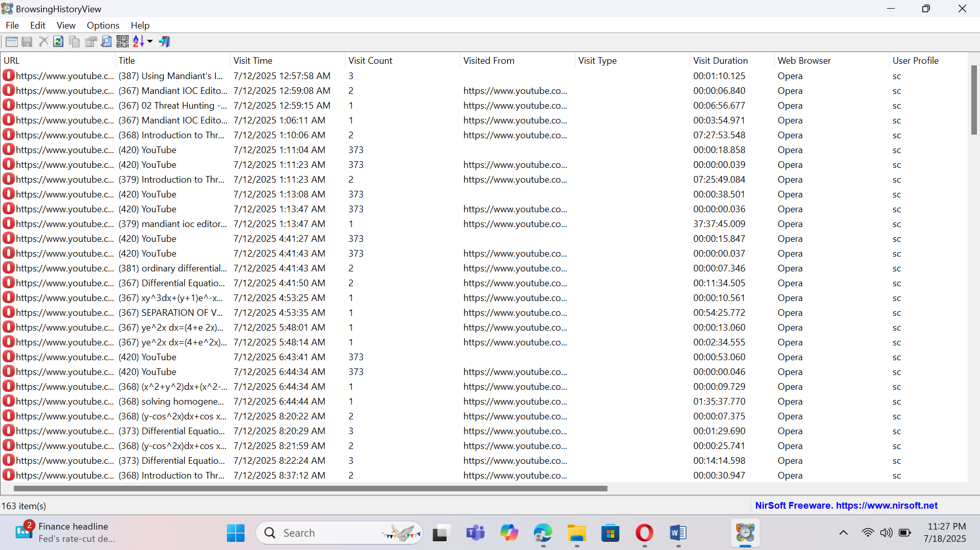

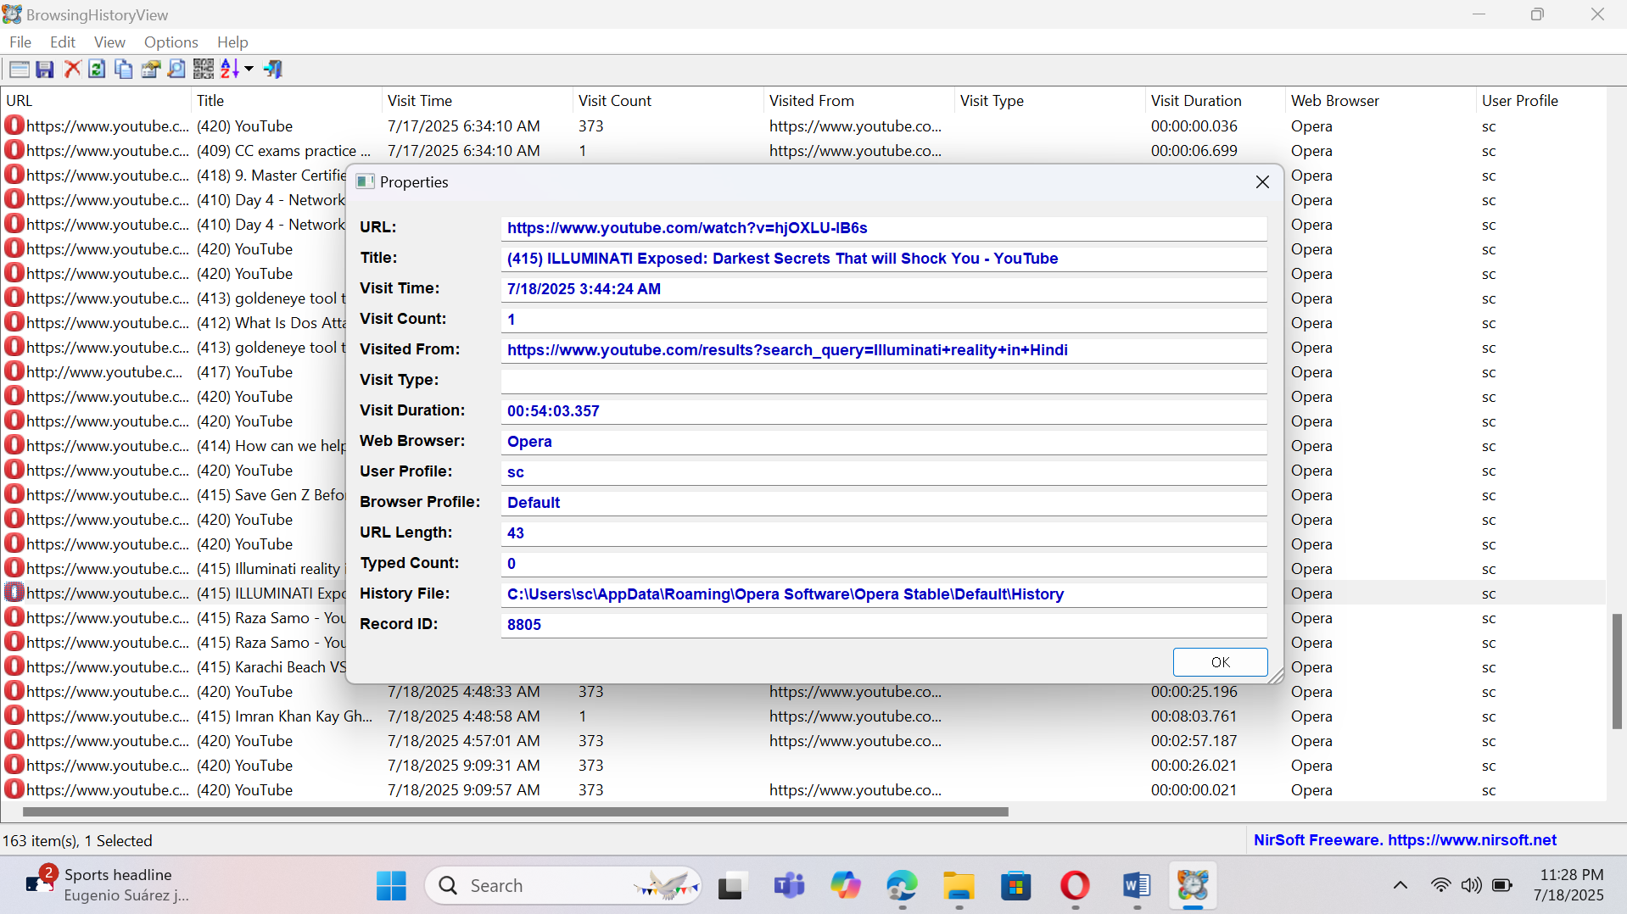

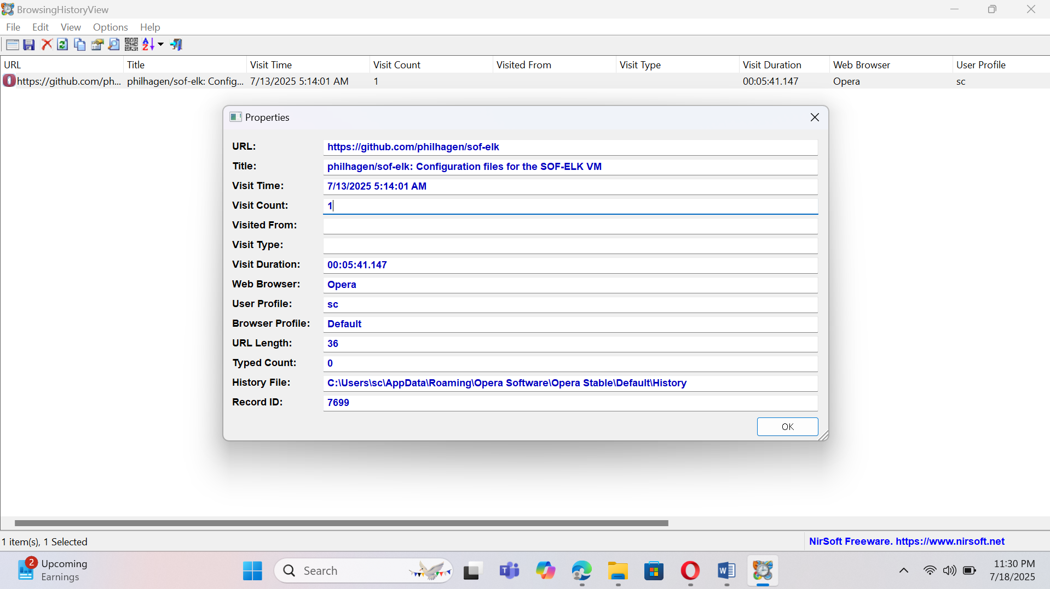

# Question 3:

Trace at least 3 files downloaded via browser.

Link to download timestamp, user account, and file location on disk.

Note whether they were deleted or moved.

Use **DB Browser for SQLite** to query:

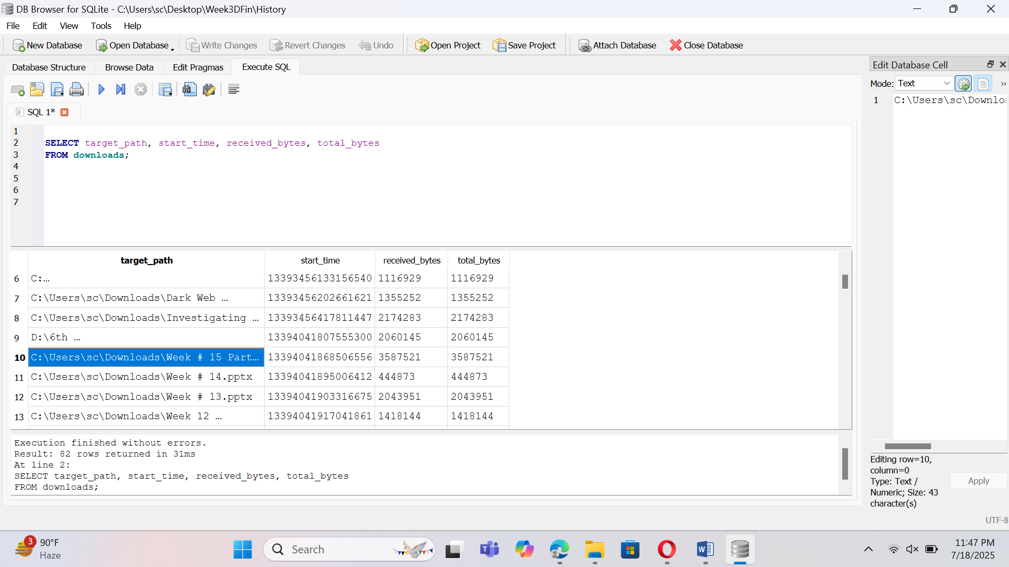

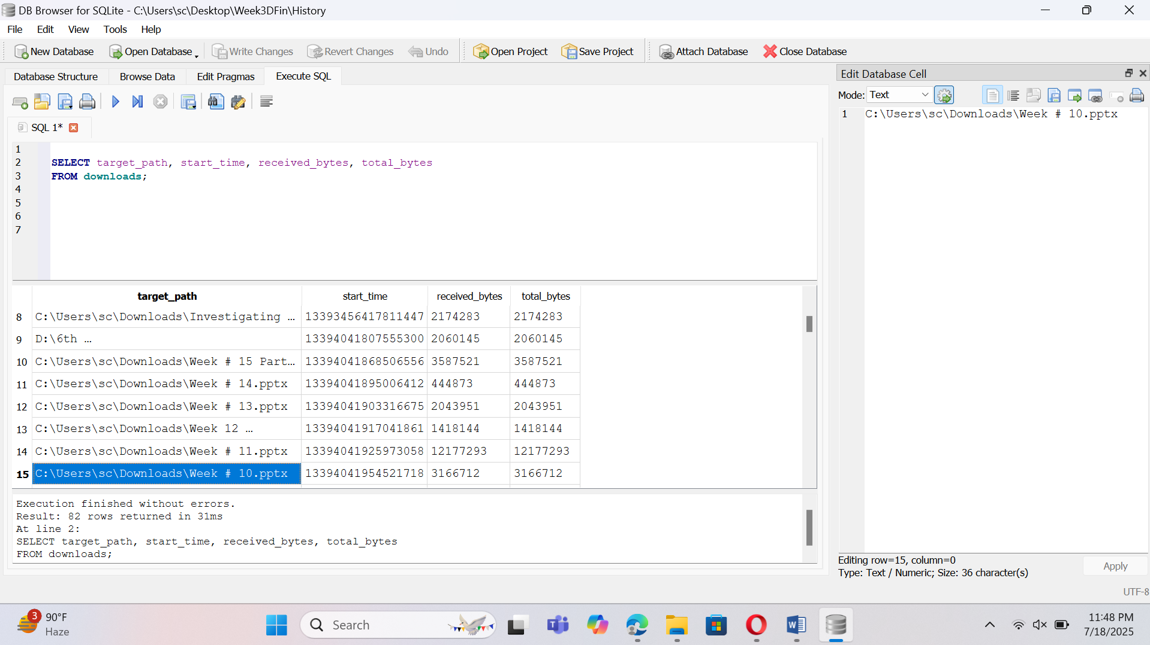

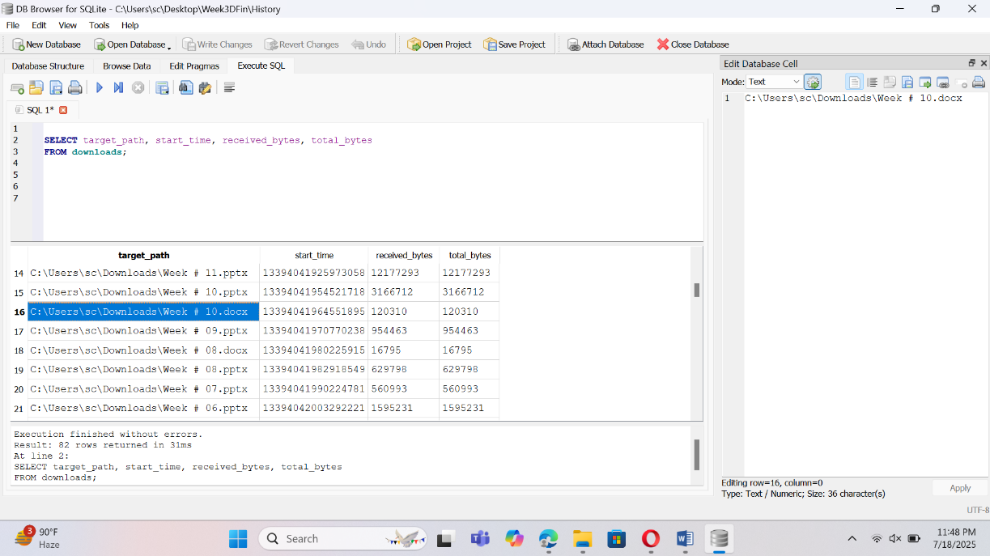

Now I will recover that files. Use EaseUS Data Recovery and select Deownload folder.

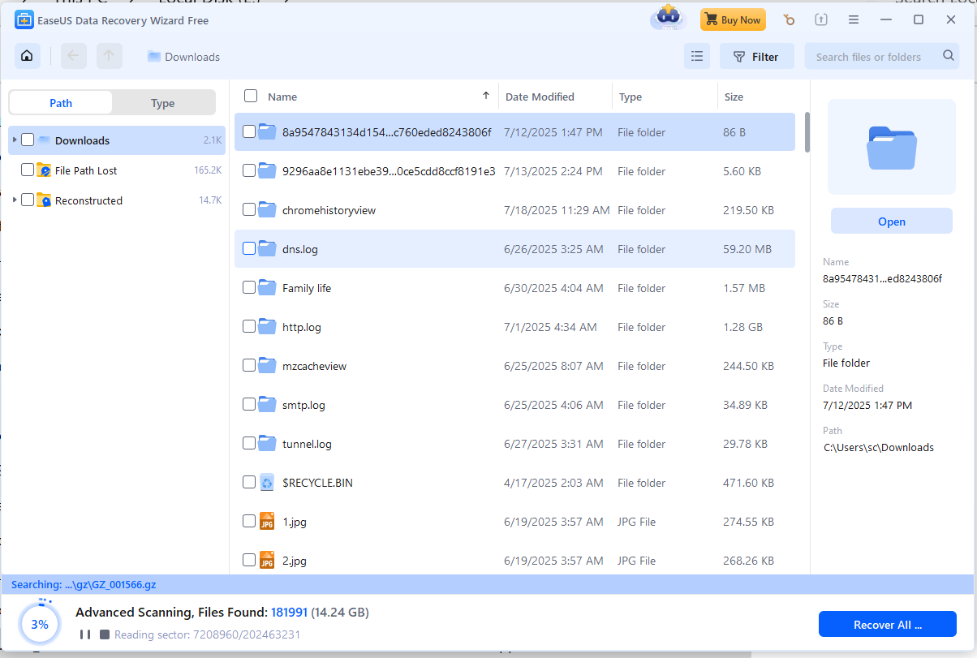

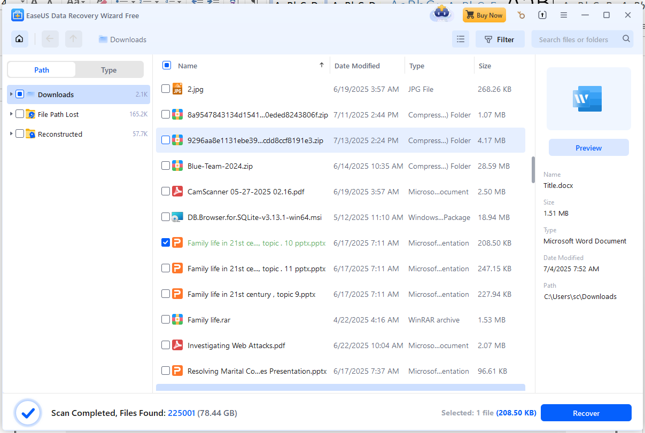

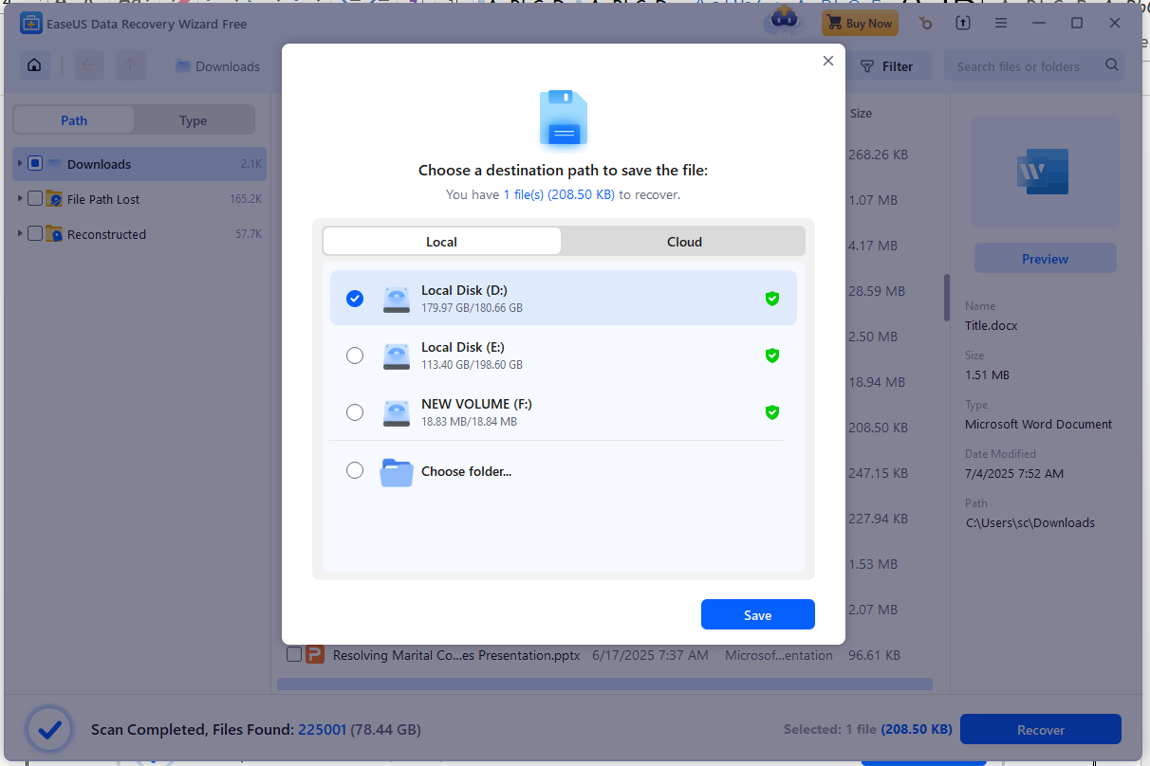

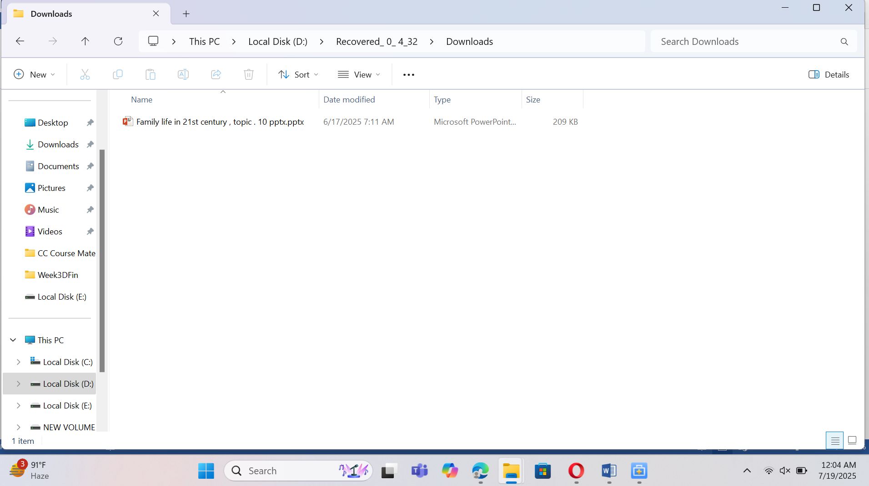

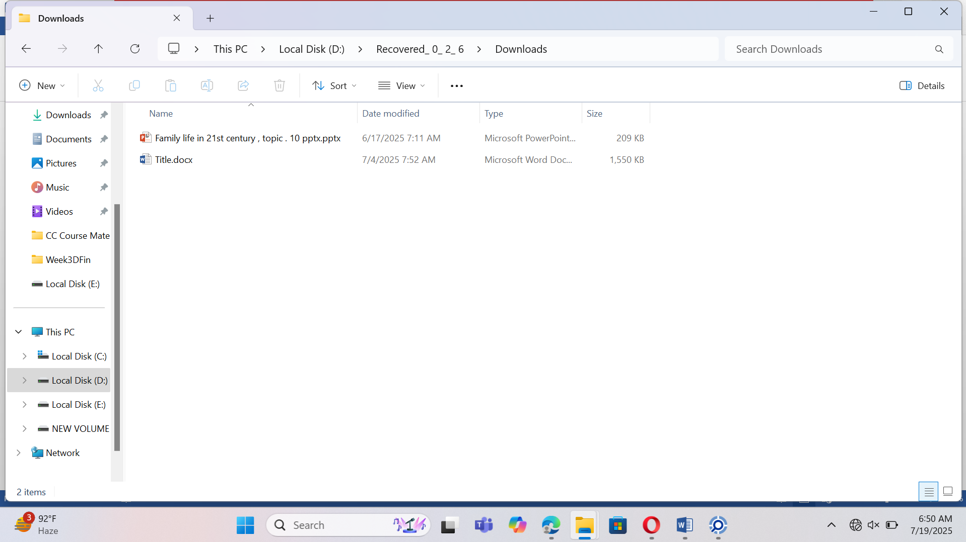

# Question: 04

Email/Webmail Analysis (Optional but Advanced)

Locate cached webmail (e.g., Gmail/Outlook) HTML or artifacts.

Identify communication involving attachments, links, or credentials.

I Use browser history database (History file from Chrome, places.sqlite for Firefox).

Look for URLs like:

* mail.google.com

Open history file in Browsing History View.

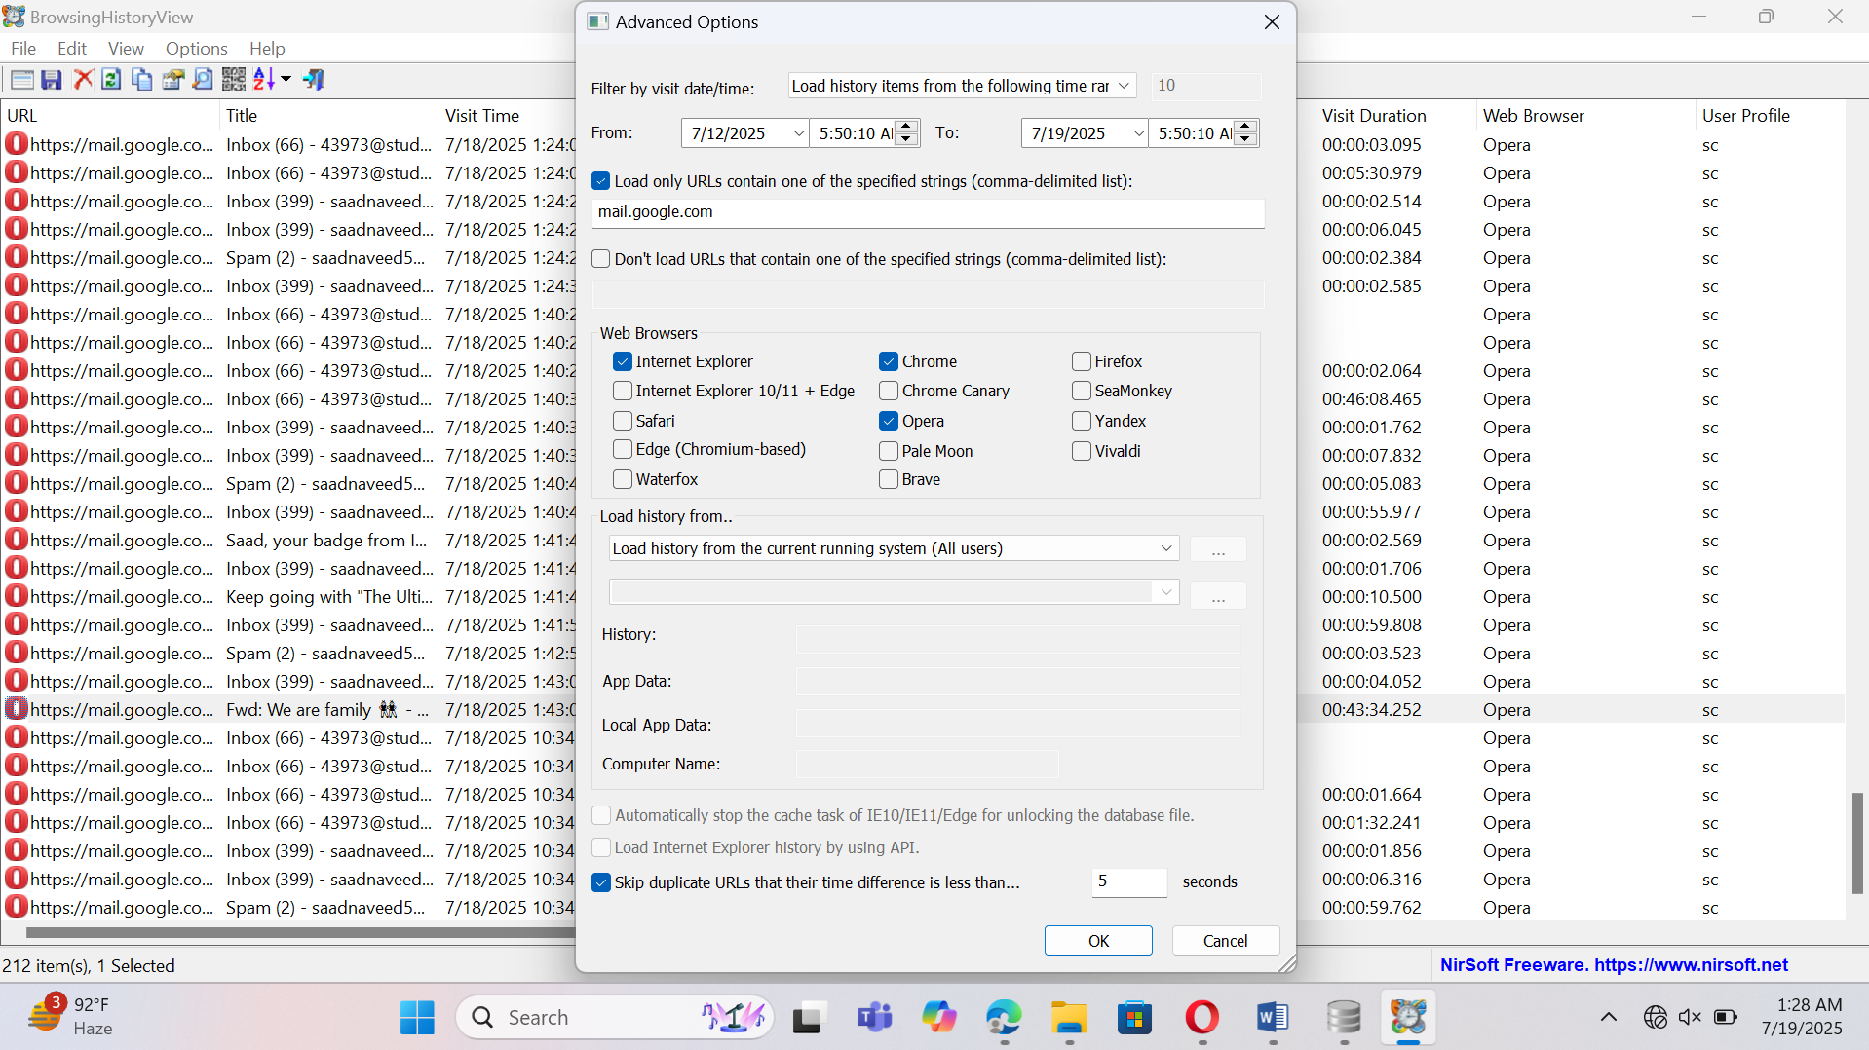

Now analyze email and attachments.

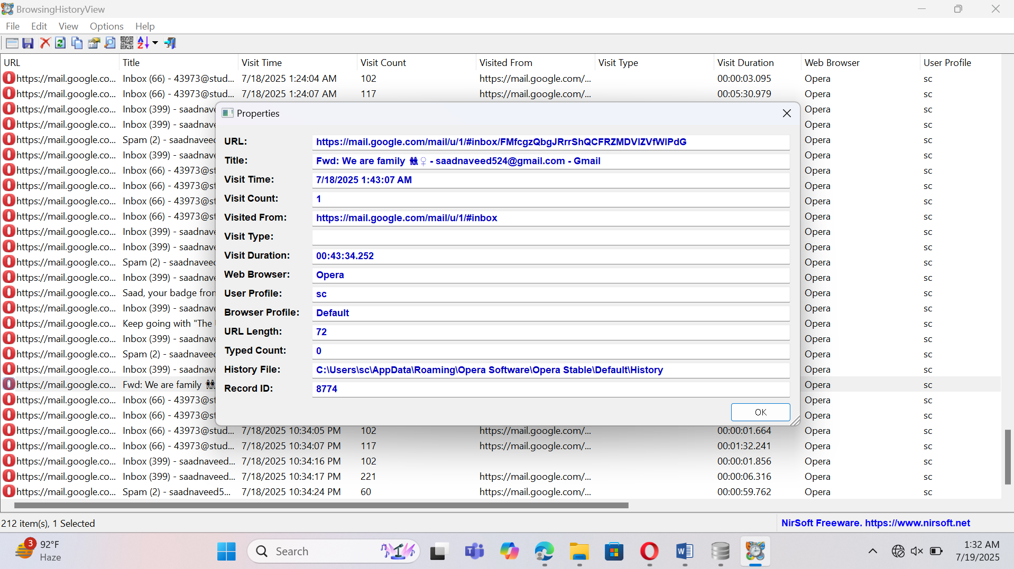

Check Webmail Session Data

Open the Cookies database (Cookies file in the browser profile).

Use **DB Browser for SQLite**

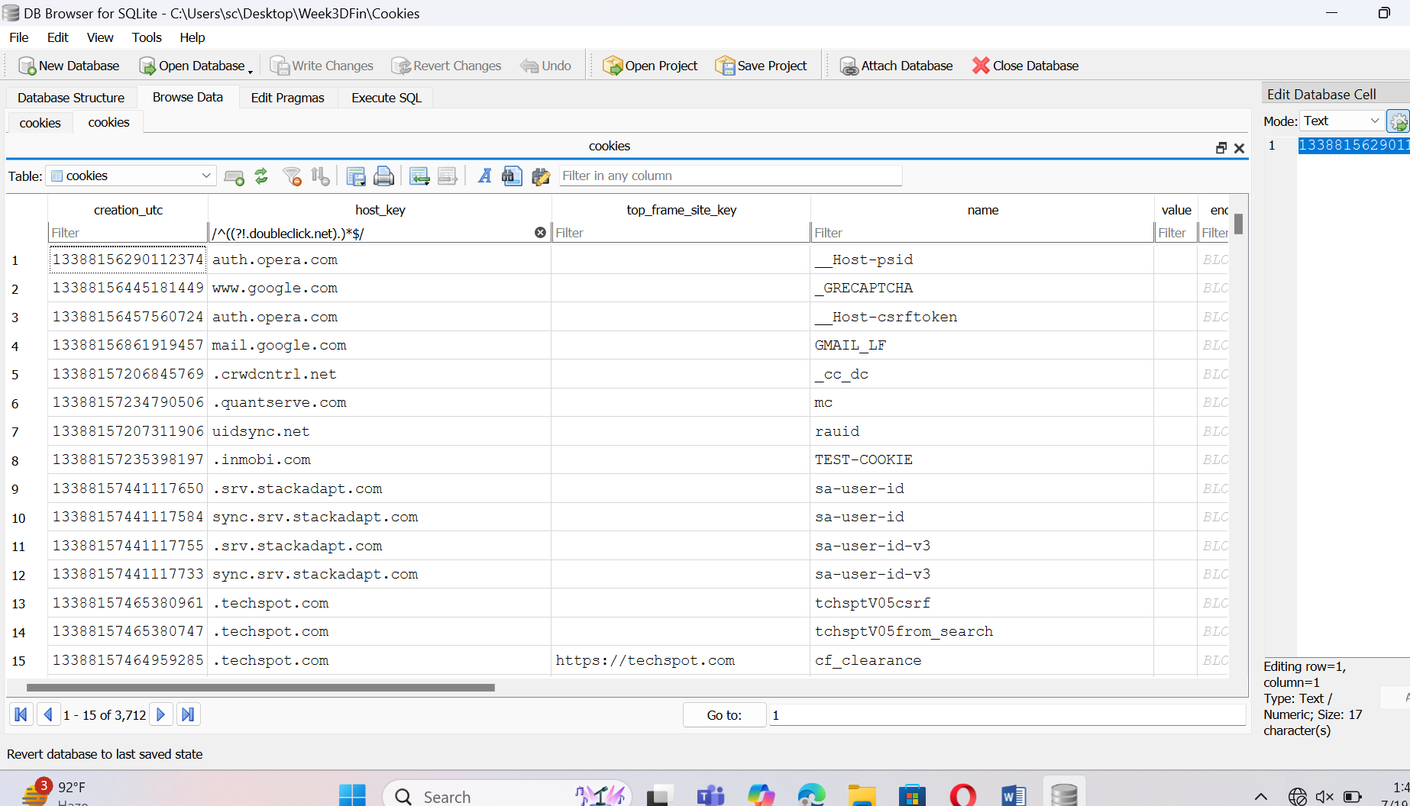

# Question 5

Cross-Reference with OS Artifacts o Check prefetch, recent files, or shellbags to confirm file execution/opening.

Tie browser use with user login sessions.

Solution:

Analyze Prefetch Files:

**Location:**  
C:\Windows\Prefetch\

**Tool:**

* Use **WinPrefetchView** (NirSoft).

**How:**

1. Open WinPrefetchView.
2. Sort by "Last Run Time".

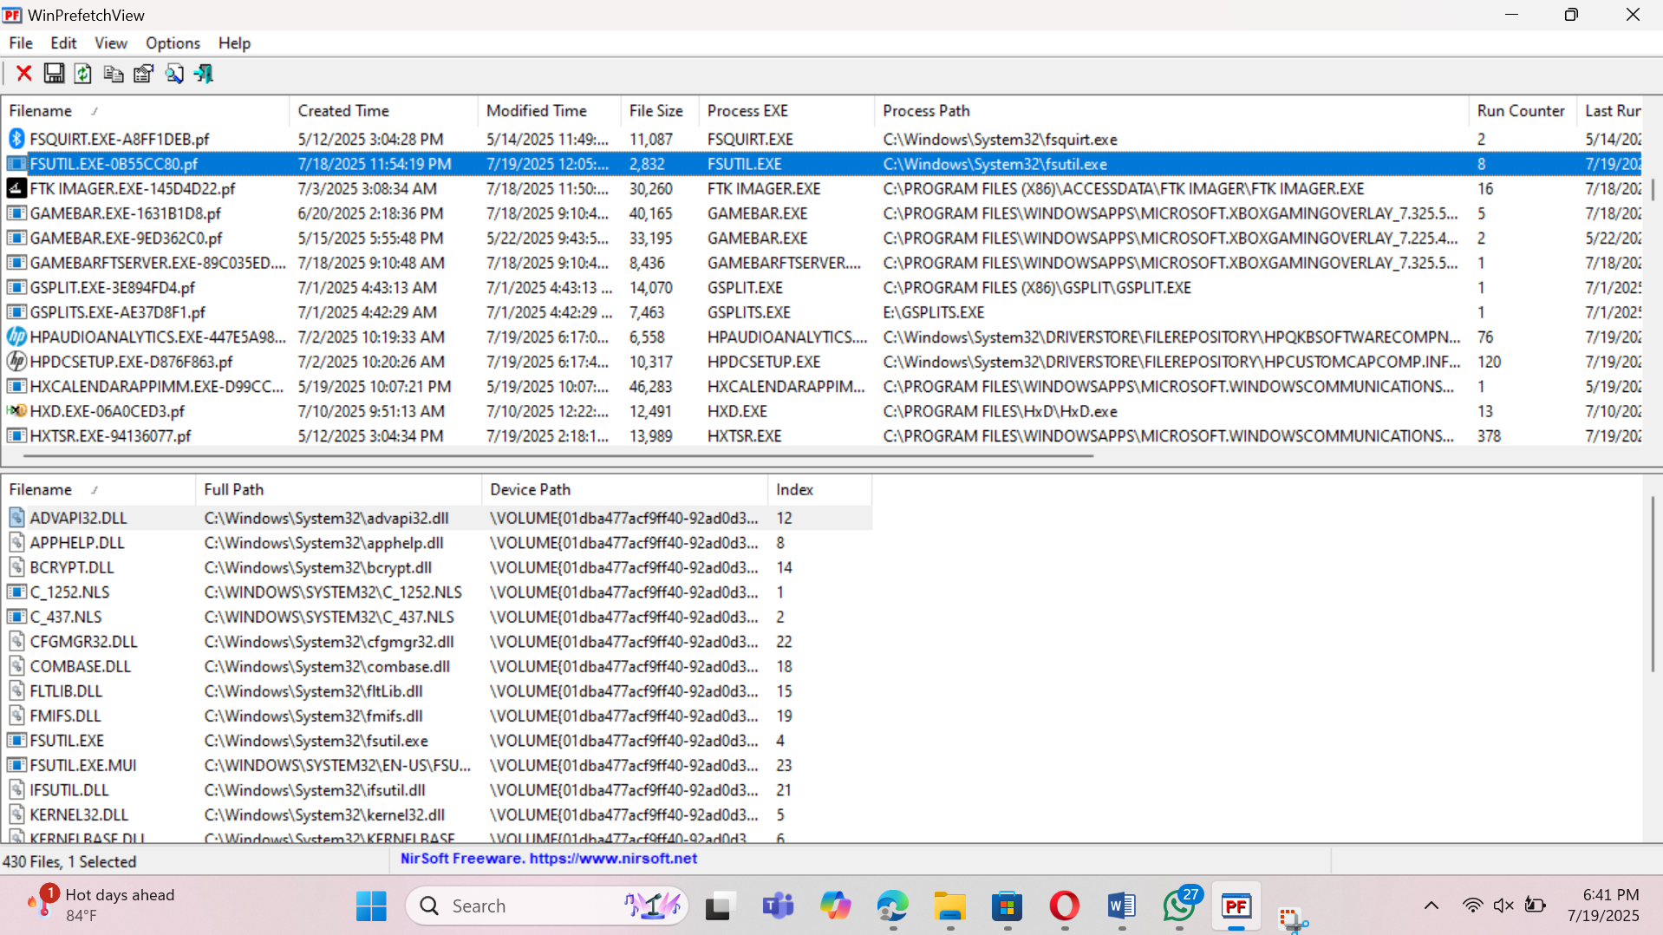

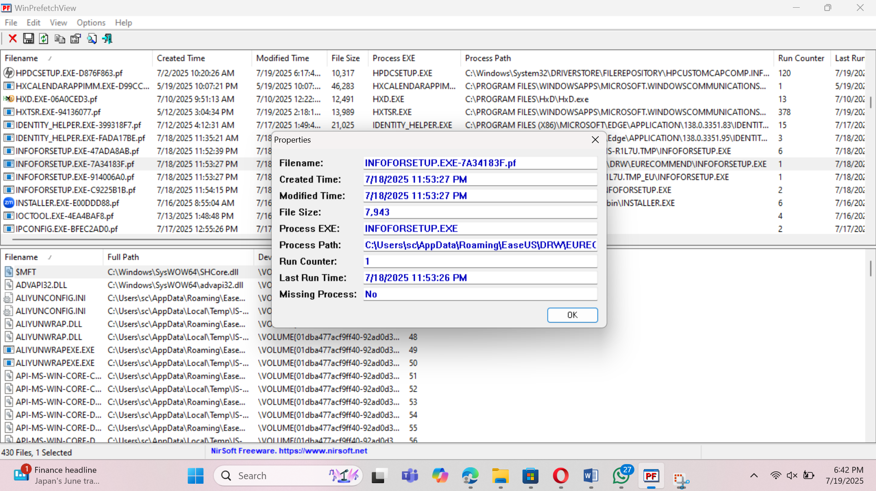

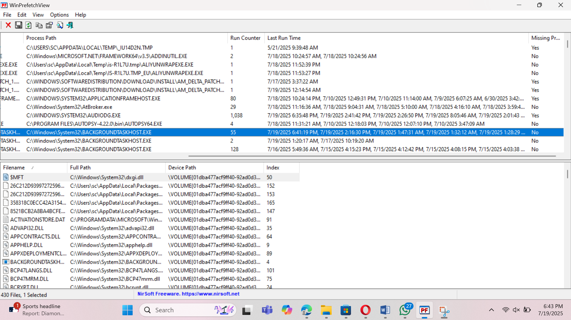

**Step 2: Check Recent Files**

**Purpose:** Windows keeps shortcuts to recently opened files.

**Location:**  
Check the Opera download directory (Opera’s default path is:  
C:\Users\sc\Downloads.

Open any file from there, and a .lnk shortcut will appear in **Recent Files**.

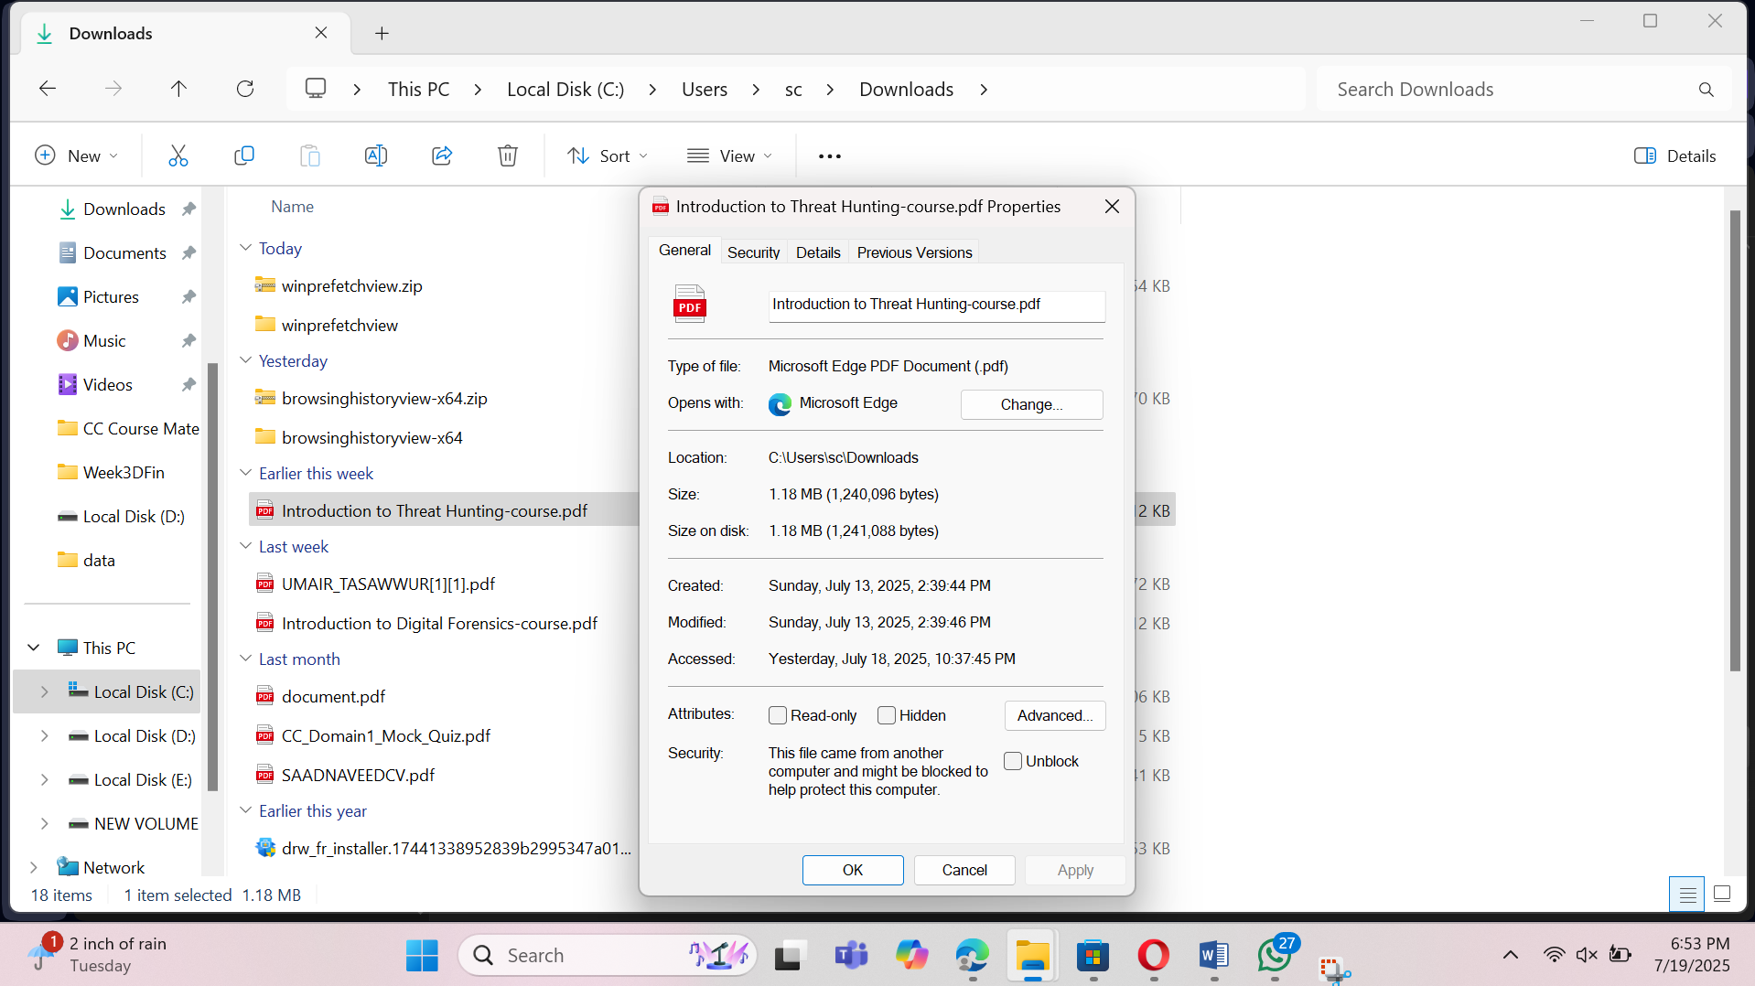

### ****Step 3: Analyze Shellbags****

**Purpose:** Shellbags show folder browsing history (useful to know if the user opened the Downloads folder).

**Tool:**

* **ShellBags Explorer** (Eric Zimmerman’s tool).

**How:**

1. Open ShellBags Explorer.
2. Search for Downloads folder navigation.
3. Check timestamp when that folder was accessed.

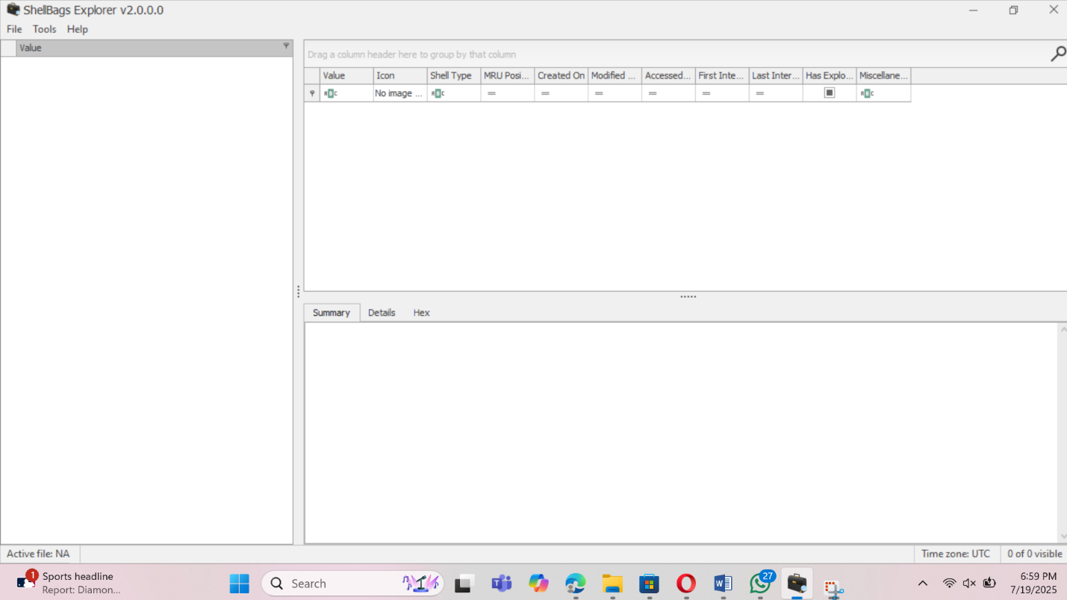Shell Bag open.

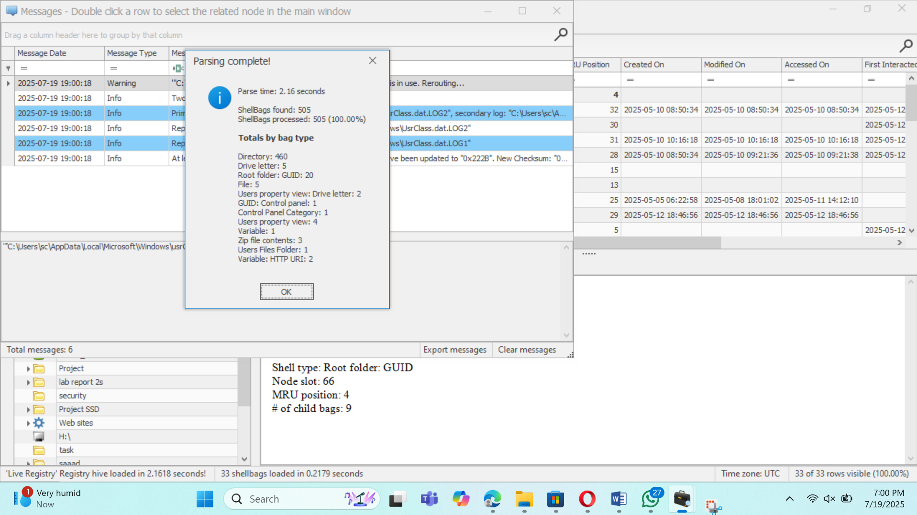

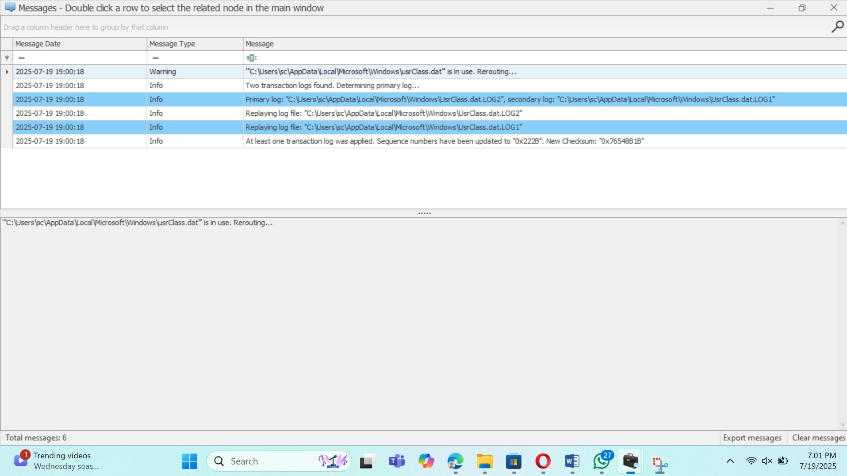

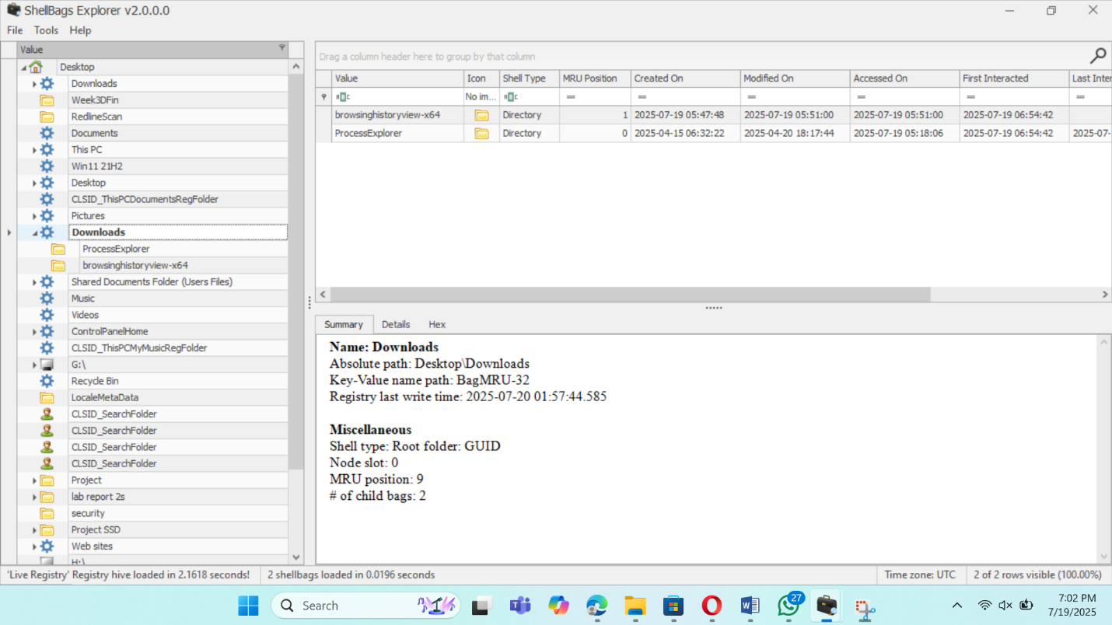This is showing folder accessing time.

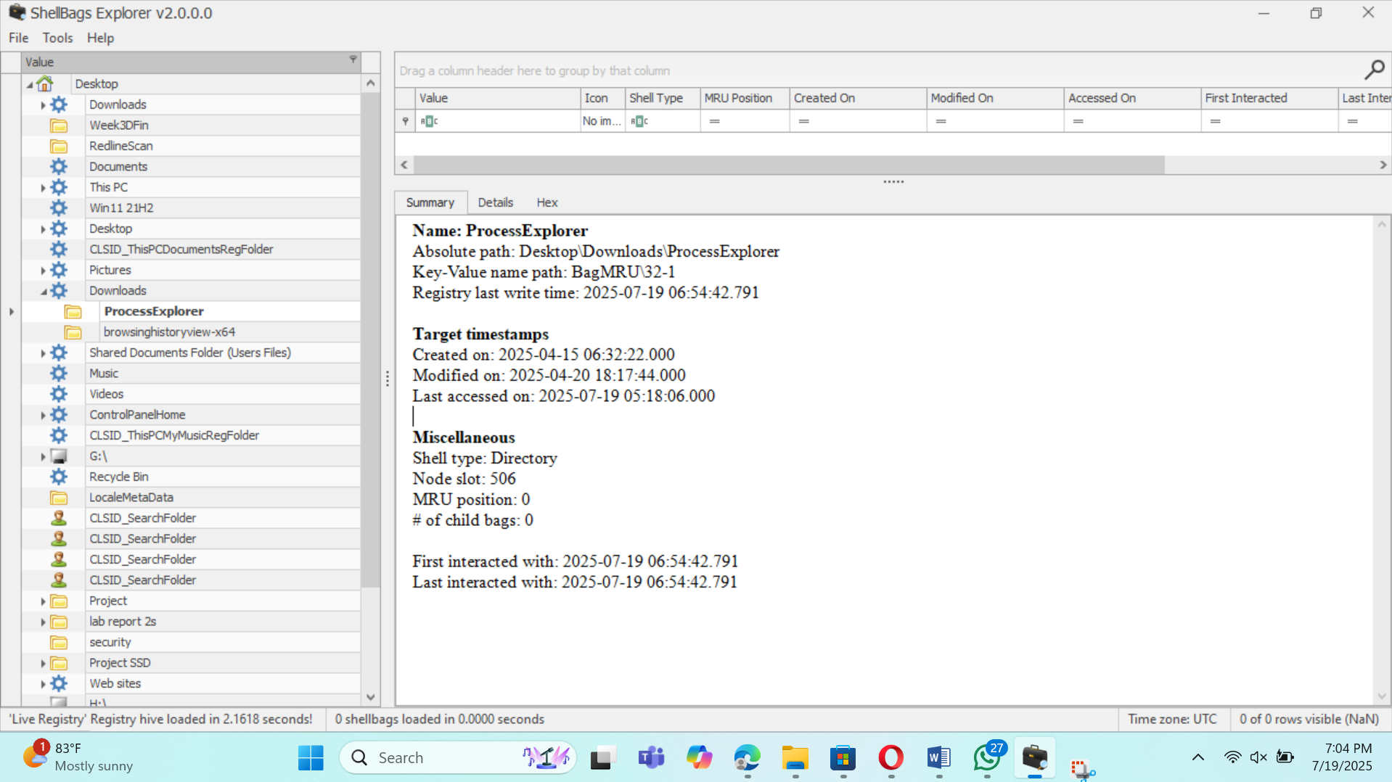

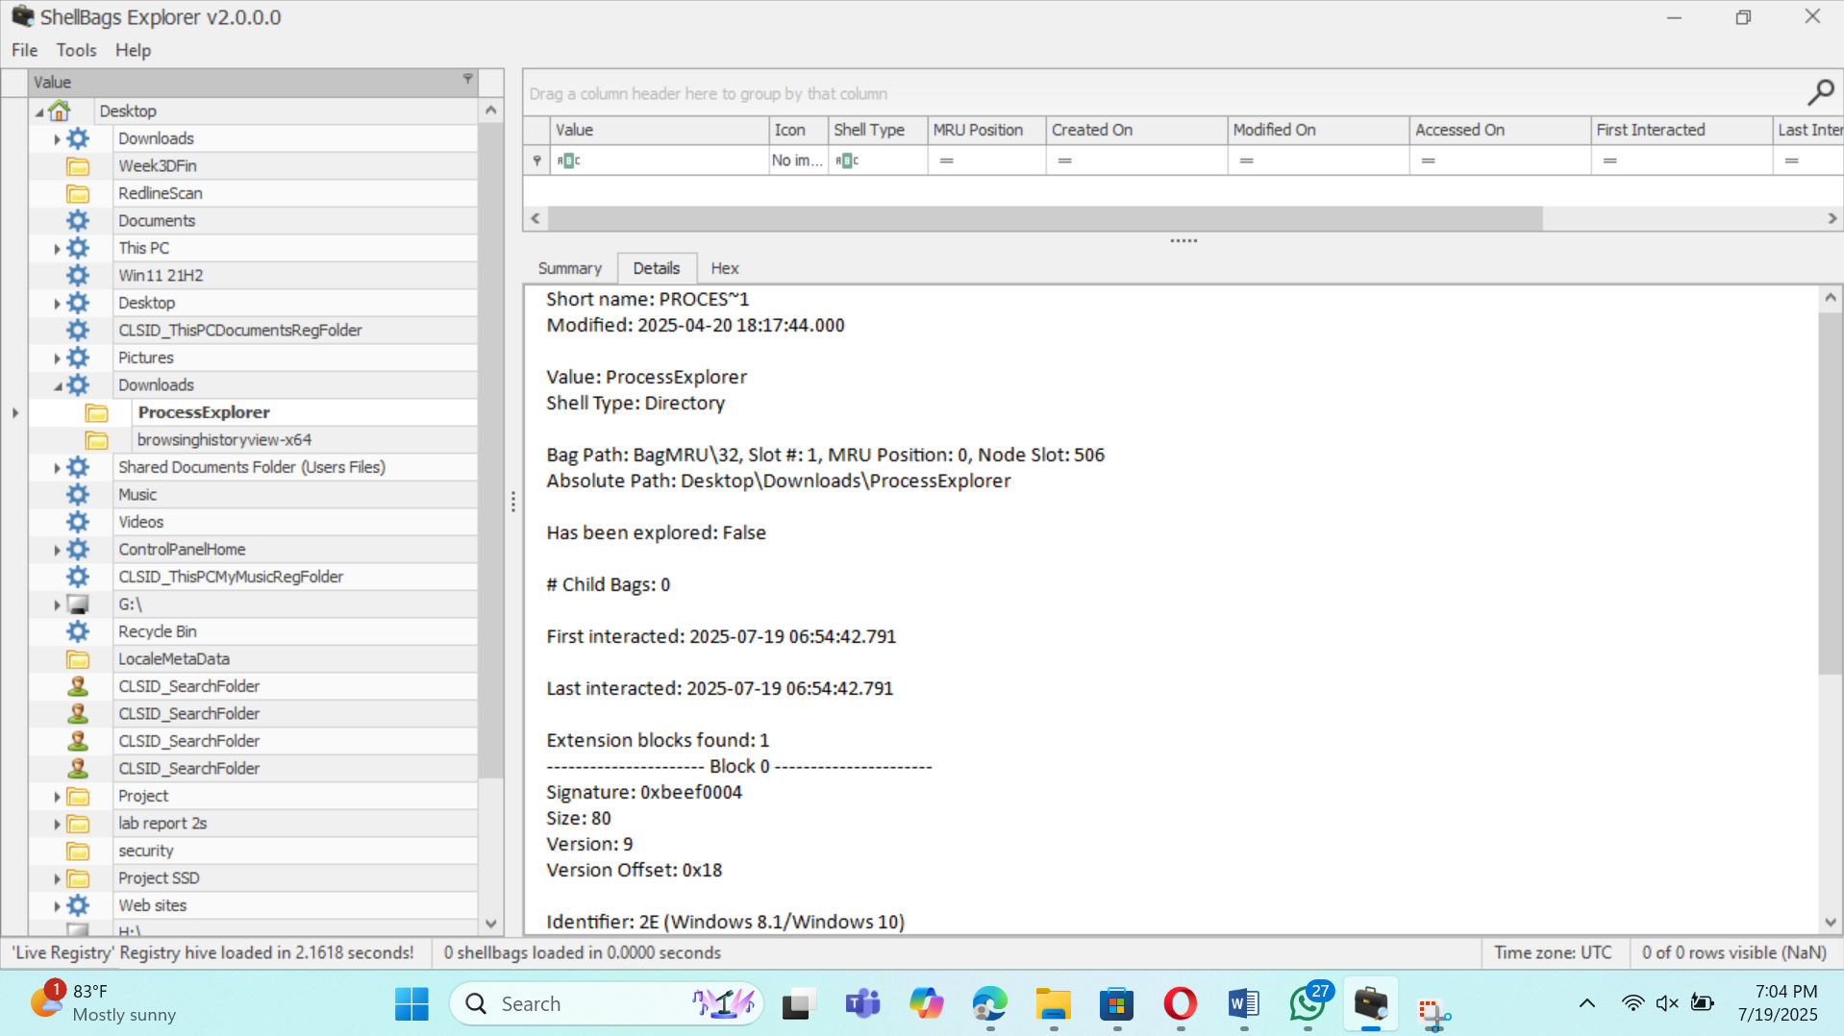

### ****Step 4: Correlate with Event Logs (User Login Sessions)****

**Purpose:** Ensure the browser activity matches a particular user login session.

**Location:**

* Event Viewer → **Windows Logs** → **Security**
  + Look for **Event ID 4624 (Logon)**.

**How:**

1. Open **Event Viewer**.
2. Filter security logs by Event ID 4624.

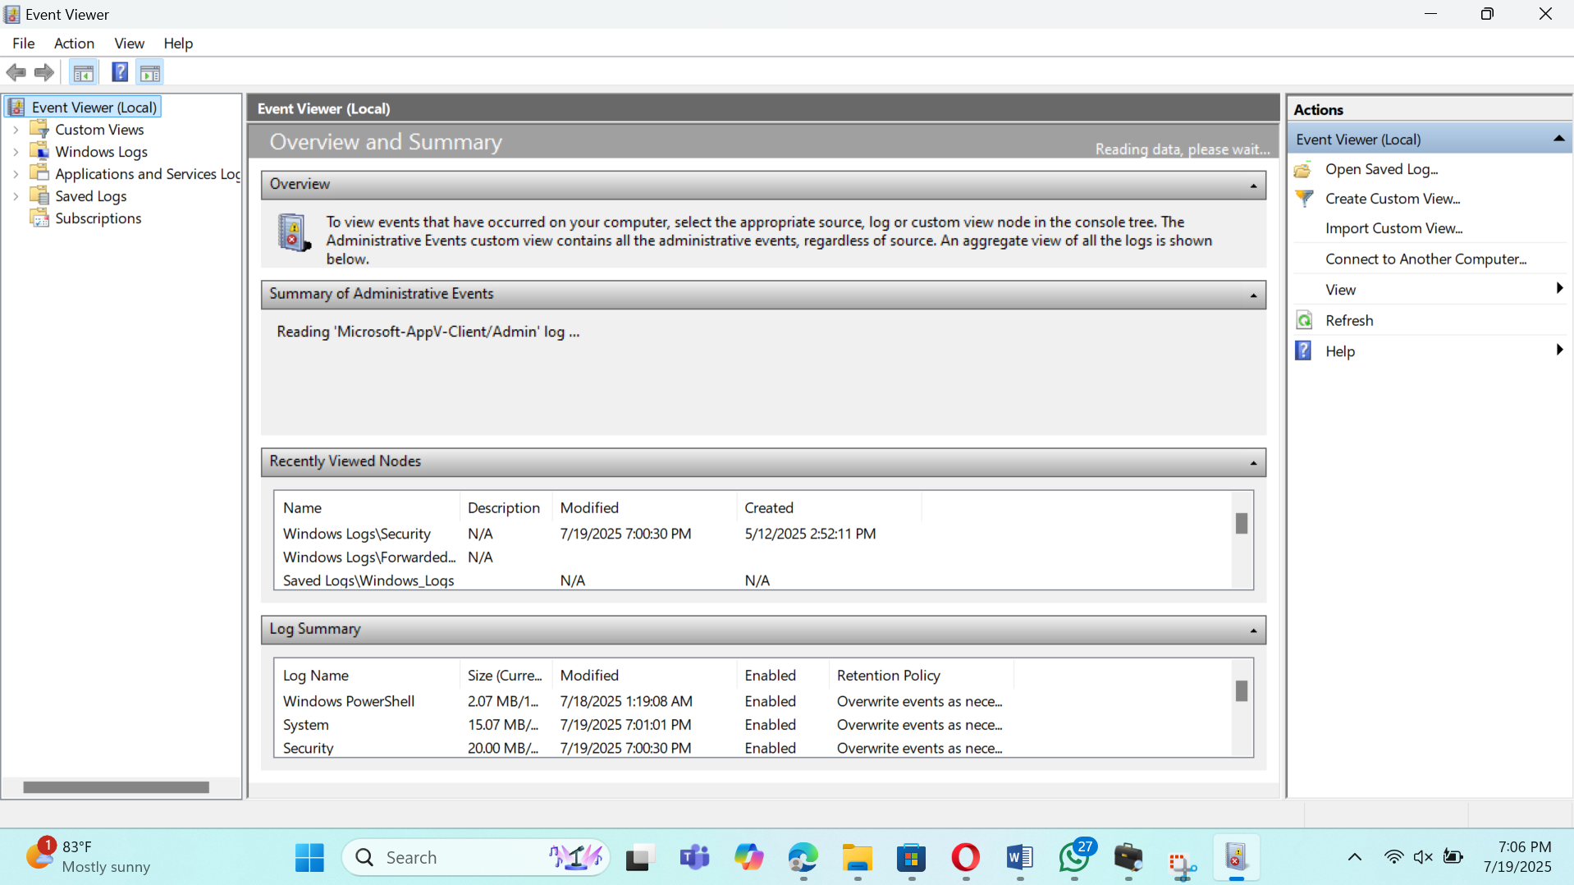

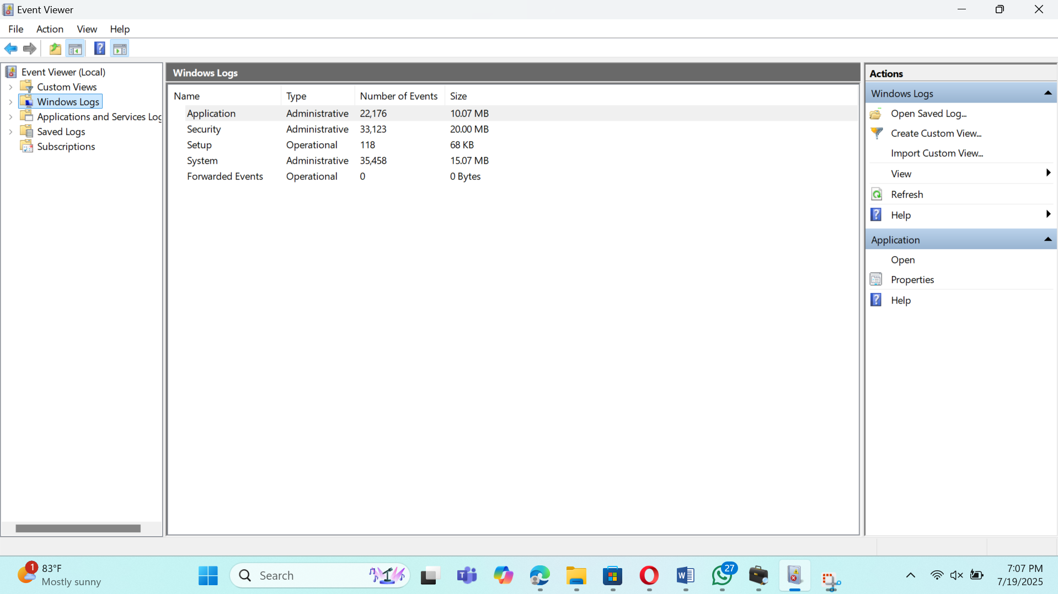

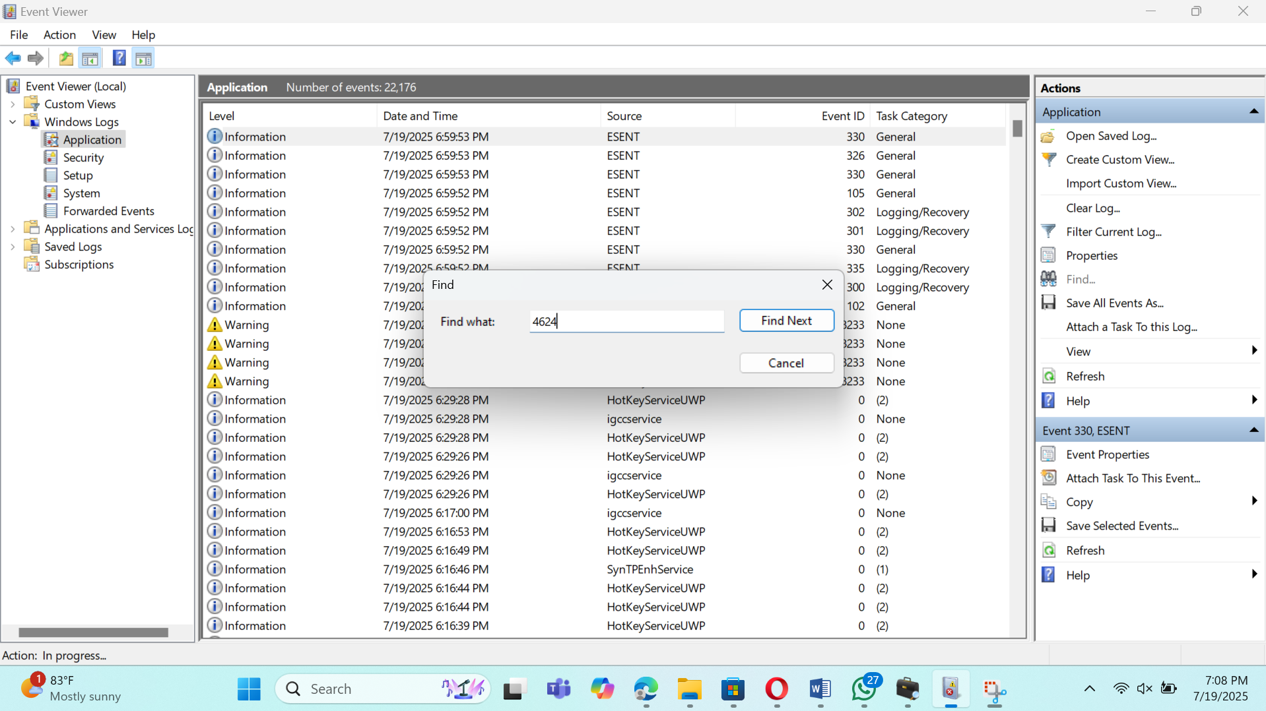

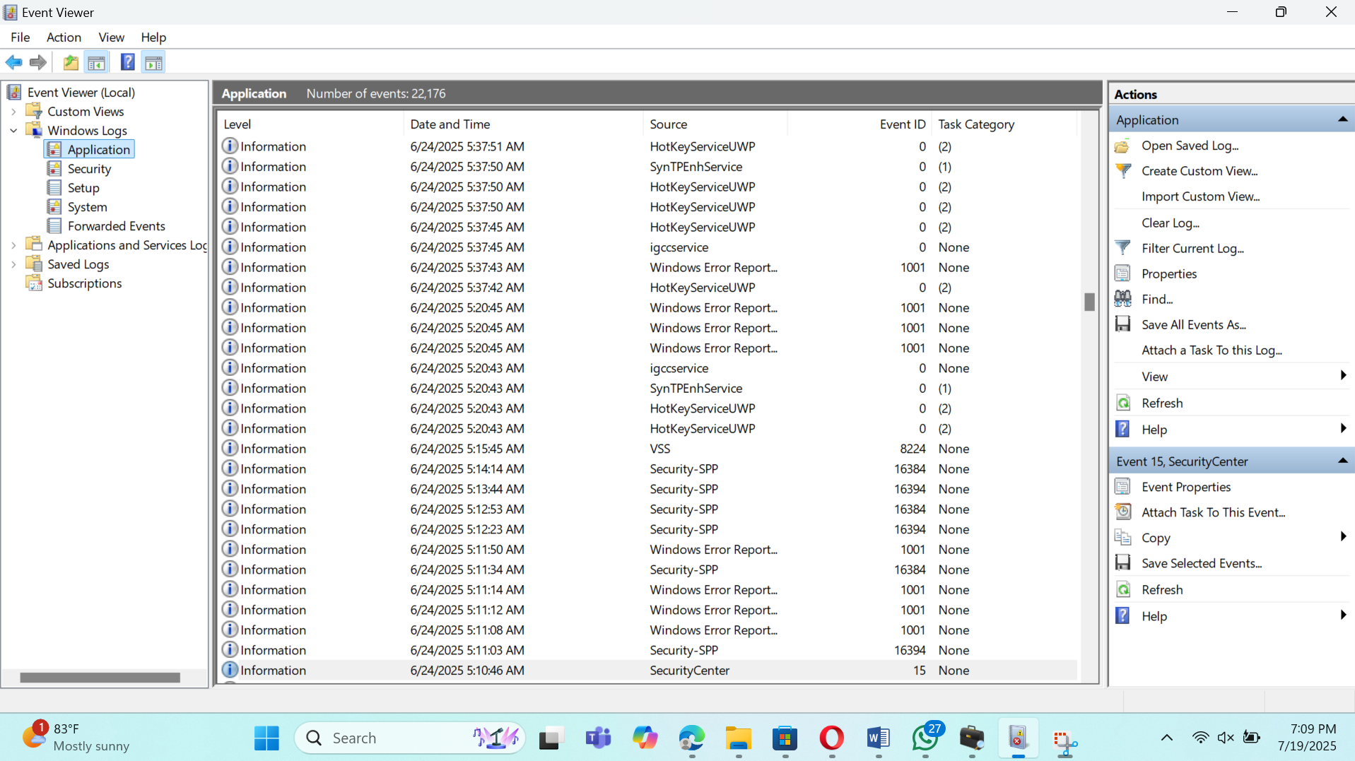

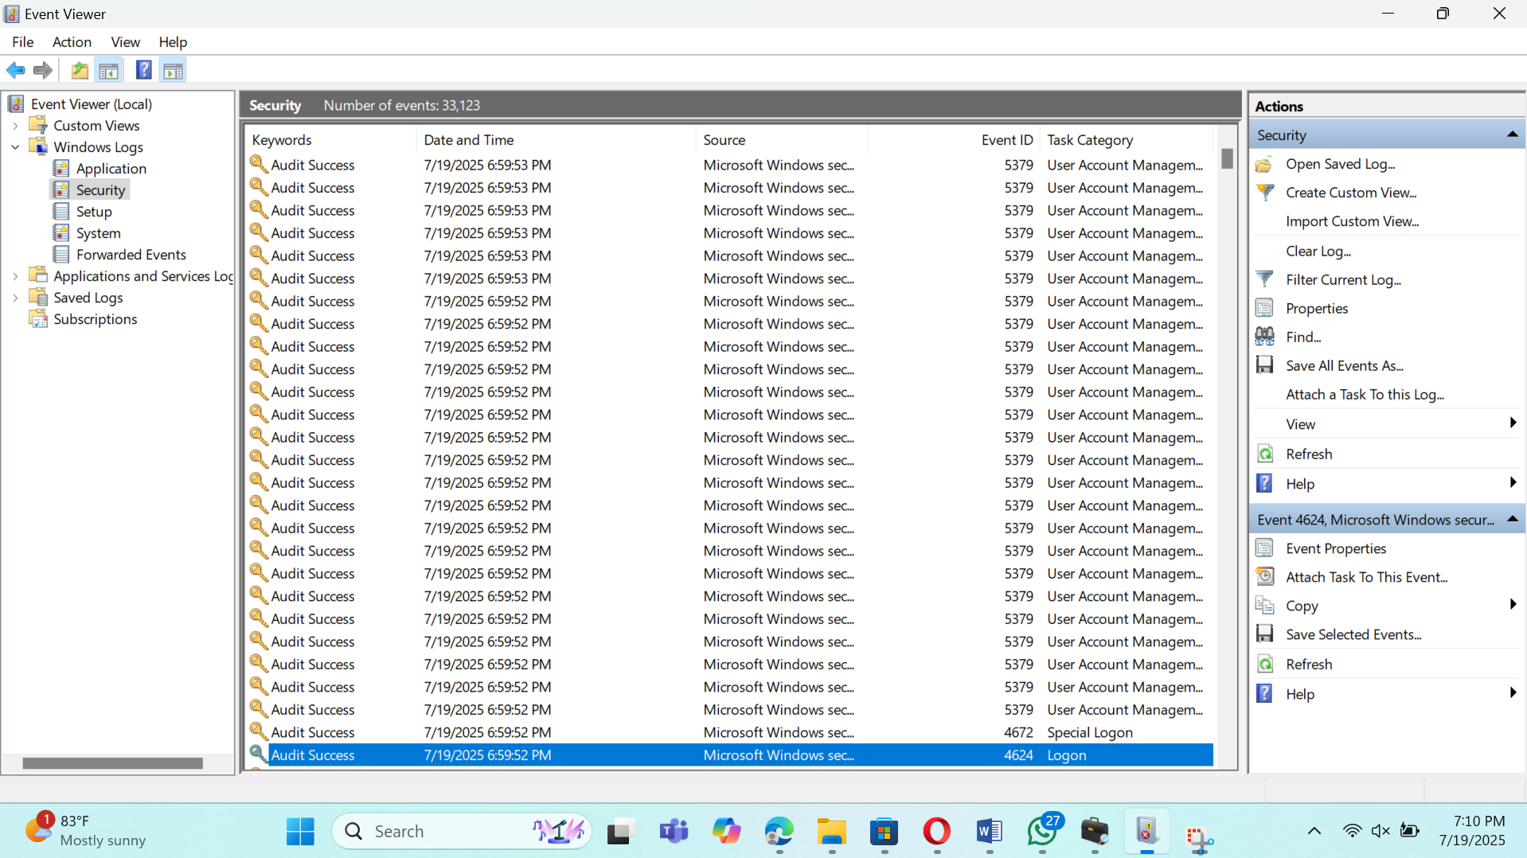

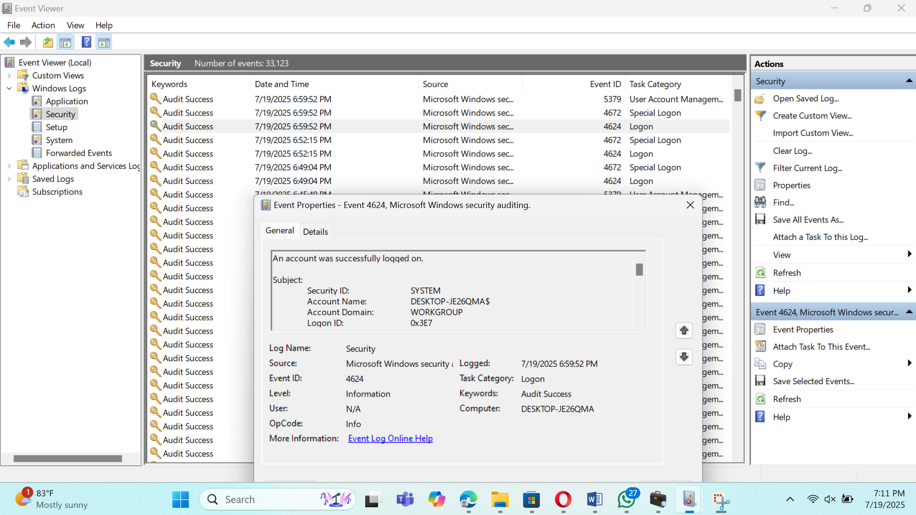

# Conclusion

In this week’s investigation, I collected and analyzed important browser data such as **history, cookies, bookmarks, login details, and downloads** from the Opera browser profile folder. I used tools like **BrowserHistoryView, DB Browser (SQLite), WinPrefetchView, ShellBags Explorer, Event Viewer, VirusTotal, and EaseUS recovery tool** to carefully examine the user’s web activity.

I checked for **suspicious websites, phishing links, and spam emails** using BrowserHistoryView and cross-checked URLs with **VirusTotal** for reputation. I also traced **downloaded files** by reviewing the downloads database and checked whether files were deleted or still present using a recovery tool. For advanced checks, I looked into **Gmail webmail activity** using browser history and cookies.

To confirm whether the downloaded files were opened or executed, I analyzed **Windows Prefetch files, Shellbags, and Security Event Logs (ID 4624)**. This helped me connect the user’s web browsing with their active login sessions and confirm if files were accessed or executed.

Overall, this investigation followed a complete digital forensic approach:

* **Collecting data** from the browser.
* **Checking for suspicious activity** like phishing or harmful downloads.
* **Tracing downloaded files** and recovering deleted ones.
* **Analyzing OS artifacts** to confirm file execution and user activity.

Summary  
The evidence shows a clear chain of user activity, but I still need to finalize details like:

* The list of suspicious domains and their VirusTotal results.
* The exact names, hashes, and recovery status of downloaded files.
* Confirmation of whether any cloud storage or webmail attachments were used for data transfer.

Once these details are completed, the investigation will provide a clear and reliable conclusion about any malicious or suspicious web activity.